CHAPTER 1
THE PROBLEM AND ITS BACKGROUND
1.1. Background of the Study
The complexity of the Philippine legal system presents significant barriers to justice, particularly for the marginalized and those without formal legal education. This difficulty is most pronounced in civil law, which is characterized by technical terminology and dense provisions anchored in the Civil Code of the Philippines and established jurisprudence. According to Batyushkina (2021), this "legal and linguistic uncertainty" creates a disconnect between legislative intent and the public’s ability to interpret and apply legal principles. Furthermore, empirical studies indicate that judicial documents consistently reach the highest levels of linguistic complexity, rendering them inaccessible to the average person (Golev et al., 2022).
While academic discourse within the communication field has extensively examined the psychosocial dynamics of digital spaces, specifically the correlation between social media’s aesthetic pressure and user self-esteem, there is a critical need to pivot research toward the functional utility of digital platforms for civic and legal empowerment. Existing literature often focuses on identity and behavioral effects, yet it frequently overlooks the communicative barriers that prevent digital natives from exercising their legal rights. This represents a substantial research gap: while the social implications of the digital world are well-documented, the development of communicative tools that translate complex legal structures into actionable knowledge remains neglected.
Existing digital interventions, such as the LawPhil Project, primarily serve as digital repositories for statutes and case law. While these platforms have enhanced the availability of data, they have not resolved the issue of accessibility, as they still require a high degree of legal literacy for effective interpretation. Localized attempts to bridge this gap, such as the LAWBOTS initiative at Mapúa University, have explored the utilization of AI chatbots for legal advising within the Philippine context (Sedilla et al., 2024). However, the efficacy of such tools is often hampered by the inherent limitations of the foundational models they utilize.
A critical challenge in deploying these conversational agents is the "Jurisdictional and Legal-System Specificity" gap. Recent studies demonstrate that Large Language Models (LLMs) are predominantly trained on Western-centric, US-centric corpora, causing them to absorb and reflect cultural and legal biases from those specific sources (Santurkar et al., 2023). This leads to a systematic "spatial and temporal bias," where models trained on foreign data sets inadvertently misapply foreign legal norms to disparate jurisdictions (Czarnetzki & Schiller, 2024). For civil-law jurisdictions like the Philippines, this underrepresentation in global NLP training data constitutes a significant technical hurdle, as standard models lack the specialized grounding required to navigate non-Western legal traditions (Hershcovich et al., 2022).
In response to these challenges, the Supreme Court of the Philippines adopted the Strategic Plan for Judicial Innovations (SPJI) 2022–2027 and the Governance Framework on the Use of Human-Centered Augmented Intelligence (A.M. No. 25-11-28-SC) in 2026. These policies mandate that technological advancements in the judiciary must be "understandable and intelligible to the public" (Supreme Court of the Philippines, 2026). This study aligns with these national mandates by proposing CIVIL LEX, a Retrieval-Augmented Generation (RAG) framework. Unlike standard NLP simplifications (Del Rosario et al., 2015) or simple document retrieval systems (Andrews et al., 2024), CIVIL LEX leverages transformer-based models and a localized knowledge base to provide explainable, context-aware interpretations of Philippine civil law. By grounding the generation process in verified local statutes, the framework mitigates the US-centric biases inherent in general LLMs, translating complex legal language into a comprehensible roadmap for legal action and fostering greater judicial inclusivity in the Philippines.
1.2. Statement of the Problem
The primary problem of this study is how to develop CIVIL LEX, a Retrieval-Augmented Generation (RAG) framework that utilizes transformer-based neural networks to provide explainable and simplified interpretations of Philippine Civil Law.
Specifically, this research seeks to address the following questions:
- How can the Civil Code of the Philippines (RA 386) and selected legal references be collected, cleaned, structured, and validated to produce a dataset suitable for the CIVIL LEX Web Application?
- How can a Retrieval-Augmented Generation (RAG) framework using transformer-based neural networks be designed and implemented to retrieve relevant legal provisions and generate simplified, explainable interpretations of Philippine Civil Law?
- What are the accuracy and reliability of the fine-tuned XLM-RoBERTa retriever and the Gemma4 (E4B) generator within the CIVIL LEX retrieval-augmented generation pipeline?
- To what extent does CIVIL LEX satisfy selected ISO/IEC 25010 quality characteristics in terms of:
- Functional Suitability;
- Performance Efficiency;
- Compatibility;
- Usability;
- Reliability;
- Security;
- Maintainability;
- Portability?

1.3. Objective of the Study
The primary objective of this research is to develop CIVIL LEX, an application that utilizes a Retrieval-Augmented Generation (RAG) framework and transformer-based neural networks to provide explainable and simplified interpretations of Philippine Civil Law.
Specifically, the study aims to achieve the following:
- To implement a data collection and preprocessing pipeline that scrapes, cleans, and segments RA 386 text into article-level records with structured metadata, incorporates jurisprudence from authoritative sources that will be validated by legal professionals, and enriches each article using large language model–based data augmentation to generate bilingual question and answer pairs, reasoning chains, simplified explanations, legal examples, and contextual caveats.
- To design and implement a Retrieval-Augmented Generation (RAG) framework utilizing a fine-tuned XLM-RoBERTa retriever for semantic encoding, Gemma4 (E4B) for grounded text generation, and a hybrid Postgresql pgvector + tsvector retrieval index fused via Reciprocal Rank Fusion (RRF) for fast and accurate context retrieval.
- To evaluate the accuracy and reliability of the fine-tuned XLM-RoBERTa retriever and the Gemma4 (E4B) generator within the CIVIL LEX pipeline, using RAGAS and an Explainability Layer.
- To evaluate the extent to which CIVIL LEX satisfies selected ISO/IEC 25010 quality characteristics in terms of:
  - Functional Suitability;
  - Performance Efficiency;
  - Compatibility;
  - Usability;
  - Reliability;
  - Security;
  - Maintainability;
  - Portability?

1.4. Theoretical Framework
The development of CIVIL LEX is anchored in several interdisciplinary theoretical domains that bridge the gap between complex statutory language and user-centric artificial intelligence. These theories provide the foundation for how legal information is retrieved, simplified, and explained to the general
Public.
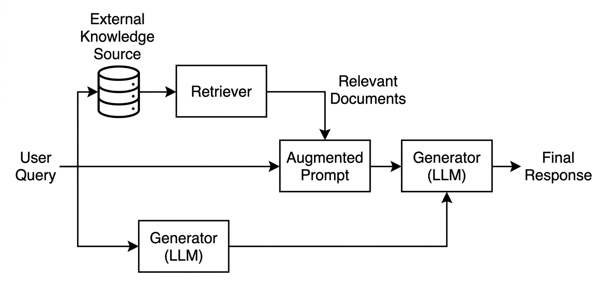
Figure 1.1 Basic RAG Architecture
Figure 1.1 represents the fundamental model of the Retrieval-Augmented Generation (RAG) concept, serving as the essential blueprint for grounding a large language model (LLM) in specialized, external data. This basic workflow operates through a linear sequence where a User Query triggers a Retriever to search an External Knowledge Source often consisting of documents cleaned and structured into formats like JSON to find the most relevant information. These retrieved segments, labeled as Relevant Documents, are then integrated into an Augmented Prompt, providing the Generator (LLM) with specific context that was not part of its original training. By following this basic architecture, the system produces a Final Response anchored in factual, external evidence, which significantly reduces the risk of AI "hallucinations" and ensures higher accuracy for specialized queries.

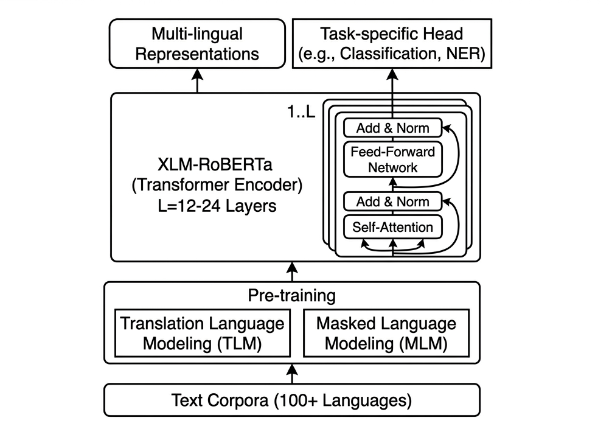

Figure 1.2 Basic XLM-Roberta Architecture
Figure 1.2 illustrates the XLM-RoBERTa (XLM-R) framework, a multilingual transformer encoder designed to generate high-quality cross-lingual representations across more than 100 languages. The process begins with extensive pre-training on diverse text corpora using Masked Language Modeling (MLM) and Translation Language Modeling (TLM) objectives to ensure deep semantic alignment between different linguistic structures. At its core, the model consists of 12 to 24 layers of transformer blocks, each utilizing self-attention mechanisms and feed-forward networks to capture complex relationships within the data. Ultimately, these refined multilingual representations are passed to task-specific heads, enabling the model to perform specialized functions such as classification or Named Entity Recognition (NER) with high accuracy.
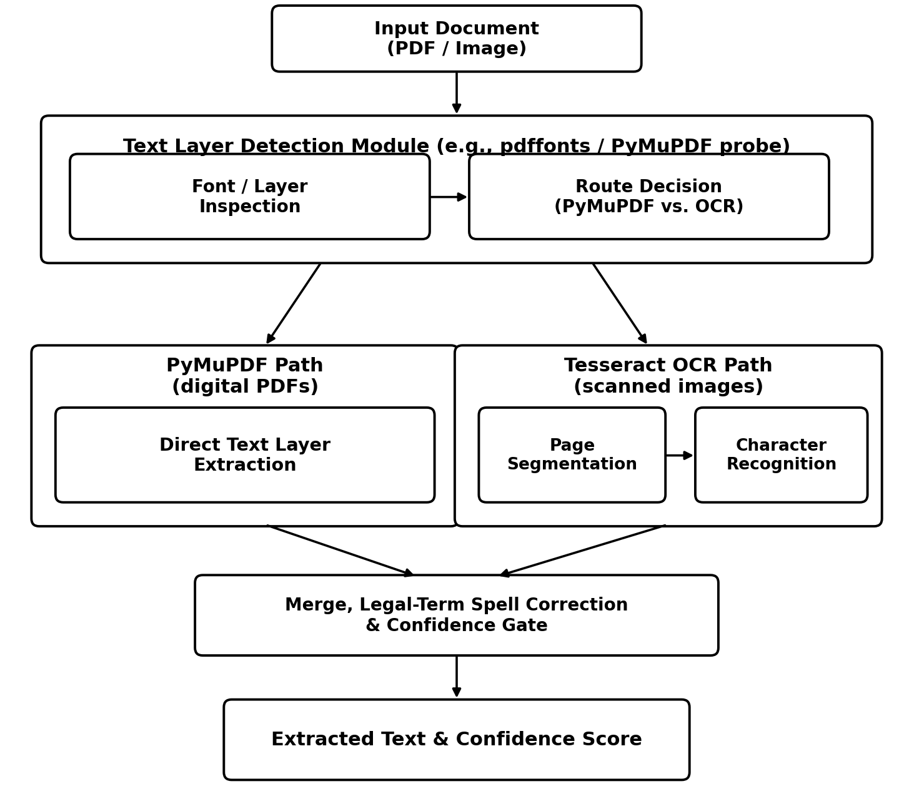
Figure 1.3 PyMuPDF + Tesseract OCR Pipeline
Figure 1.3 shows the document extraction pipeline for scanned legal documents. The workflow first attempts PyMuPDF text extraction directly from the uploaded PDF, which is fast and accurate for digitally-authored documents. If no extractable text layer is found — indicating a scanned or image-based document — the system falls back to Tesseract OCR, which performs page segmentation, character recognition, and text-line reconstruction to convert the scanned image into machine-readable text before it is merged with the user's query.
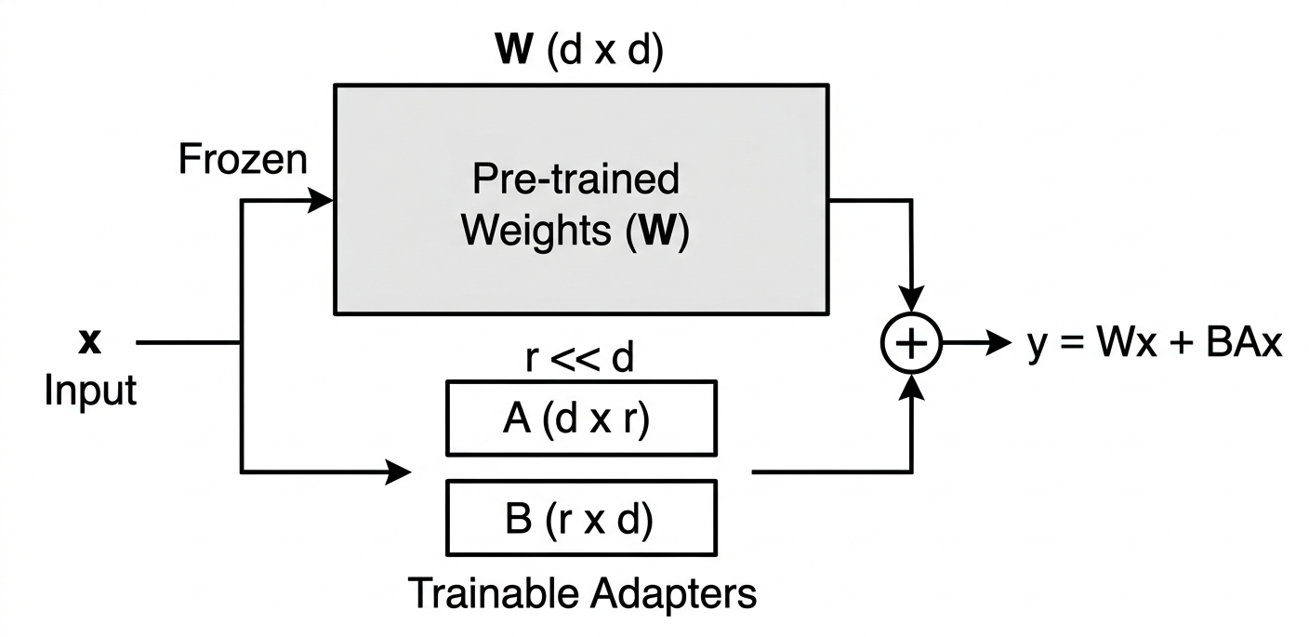
Figure 1.4 LowRank (LoRa) Adaptation of Dense Layer
Figure 1.4 shows the Low-Rank Adaptation (LoRA) of a Dense Layer, a highly efficient fine-tuning technique designed to update large pre-trained models without modifying their core parameters. The workflow begins with an Input that is processed simultaneously through two parallel pathways. The primary pathway routes the input through the original Pre-trained Weights, which remain strictly frozen to preserve foundational knowledge and drastically reduce computational memory requirements. Parallel to this, the input flows through a secondary pathway of Trainable Adapters consisting of two smaller matrices. Because the size of these new matrices is significantly smaller than the original, these adapters can learn new, task-specific features using only a fraction of the parameters. Finally, the outputs from both the frozen pre-trained weights and the streamlined trainable adapters are merged together. This merging seamlessly integrates the new capabilities while keeping the massive original architecture intact.

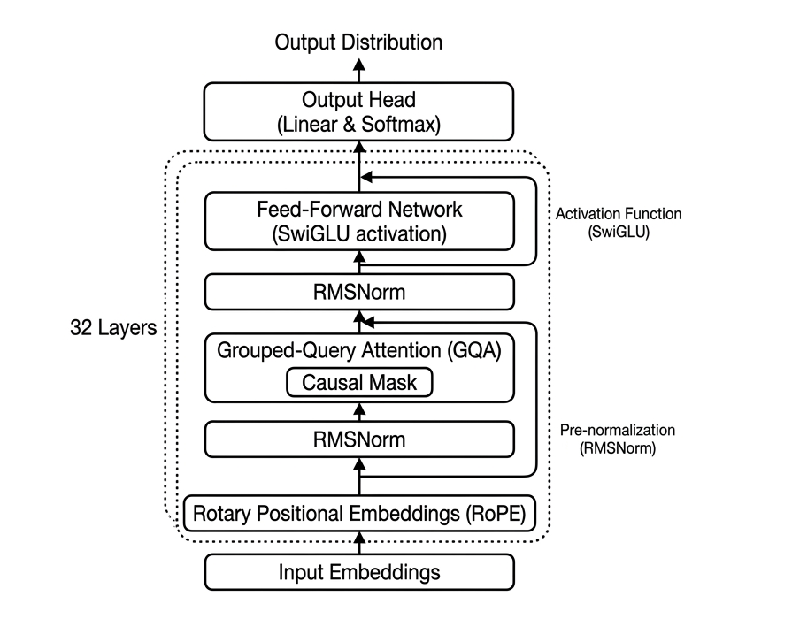
Figure 1.5 Basic Architecture of Gemma4 e4b
Figure 1.5 illustrates the transformer-based architecture of the Gemma4 e4b model, which is designed for efficient large-scale language processing. The workflow begins with input embeddings, where tokenized text is converted into dense vector representations and enhanced using Rotary Positional Embeddings (RoPE) to capture positional information. These representations are then passed through 32 stacked transformer layers that follow a pre-normalization structure, where each layer begins with RMSNorm to stabilize training. Within each layer, the model applies Grouped-Query Attention (GQA) with causal masking, enabling it to efficiently model contextual relationships while ensuring that predictions depend only on previous tokens. The output is then normalized again using RMSNorm before being processed by a Feed-Forward Network (FFN) with a SwiGLU activation function, which improves the model’s ability to learn complex patterns. After passing through all layers, the final representation is fed into an output head consisting of a linear layer and softmax function to produce a probability distribution over possible next tokens, allowing the model to perform tasks such as text generation and completion.
Communicative Legal Theory
This theory posits that the efficacy of law depends on its accessibility as a communicative tool between the state and its citizens. Batyushkina (2021) identifies a "legal and linguistic uncertainty" where the technical density of statutes like the Civil Code of the Philippines (RA 386) creates a comprehension barrier for laypersons. To address this, the study adopts the principle of functional simplification to bridge the gap between complex texts and user comprehension. This approach supports the "Functional Suitability" of the system by making legal interpretations complete yet understandable.

1.5. Conceptual Framework
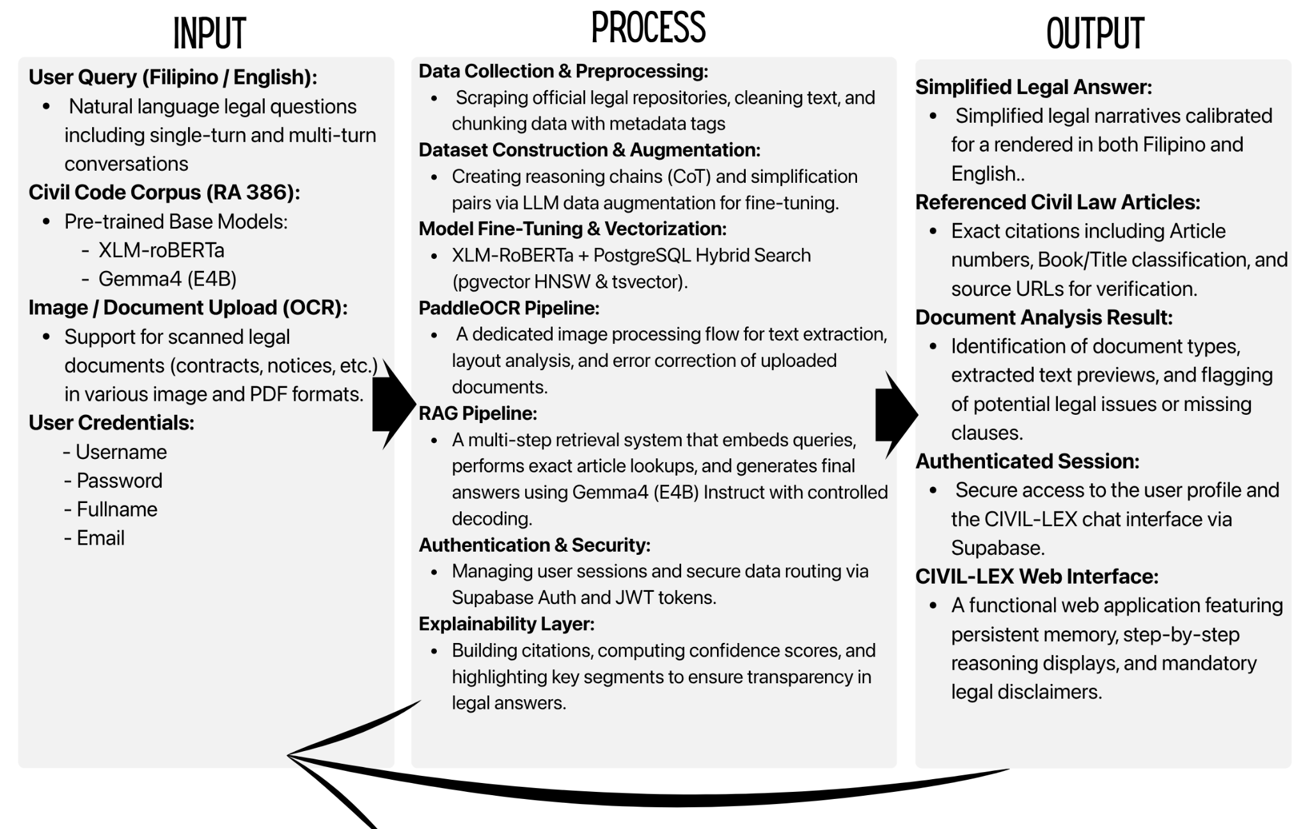
IPO (Input, Process, Output)
Figure 1. 1 Input-Process-Output(IPO) Model
The figure 1.1 illustrated using an Input-Process-Output (IPO) model that maps how Philippine Civil Code queries are received, processed, and converted into accessible legal explanations.

Input
The input component of CIVIL-LEX consists of four interconnected sources that collectively provide all information the system needs before any query is processed. The primary source is the Philippine Civil Code Corpus (Republic Act 386) with provisions explicitly updated to reflect the superseding amendments of the Family Code of the Philippines (E.O. 209). This forms the authoritative legal knowledge base encompassing the Preliminary Title and all four Books: Book I on Persons, Book II on Property, Ownership, and its Modifications, Book III on Different Modes of Acquiring Ownership, and Book IV on Obligations and Contracts. The corpus is sourced directly from official Philippine government legal repositories, preserving verbatim text for traceability, and includes authentic supplementary Supreme Court decisions linked for interpretive context. Each article is enriched through data augmentation using a large language model, which generates per-article bilingual Q&A pairs, chain-of-thought reasoning chains, plain-language simplifications in Filipino and English, real-life legal examples, legal caveats, structured debates, and document analysis examples. Crucially, jurisprudence entries with G.R. numbers and ruling summaries are strictly extracted from verified legal databases rather than synthetically generated by the LLM, ensuring factual accuracy. This structured dataset enables the fine-tuned model to reason, explain, simplify, and argue legal provisions rather than merely retrieve them. The computational foundation consists of two pre-trained base models: XLM-RoBERTa for multilingual sentence encoding and cross-lingual semantic retrieval of Filipino-English and code-switched queries, and Gemma4 (E4B) as the instruction-tuned generator base for grounded legal explanation and bilingual response generation, served via LM Studio with Groq or Gemini Flash as cloud fallback for reliability. At runtime, users submit either text queries in Filipino, English, or code-switched combinations covering any Philippine Civil Code provision, or image files of scanned legal documents (e.g., contracts, promissory notes, demand letters, court notices), which the system processes through the PyMuPDF + Tesseract OCR pipeline to extract textual content before legal analysis proceeds.

Process
The process component transforms inputs into legal responses through six sequential stages, with the first three executed offline before deployment and the remaining three at runtime. The offline build begins with Data Collection and Preprocessing, where Republic Act 386 is scraped from official repositories, cleaned and normalized to remove encoding artifacts, chunked at the article level into 2,270 structured records, and tagged with metadata including article number, Book, Title, Chapter, domain tags, and status flags for effectiveness and amendments. This is followed by Dataset Construction and Data Augmentation, where a large language model generates the nine categories of augmented fields bilingual Q&A pairs, reasoning chains, simplified explanations, legal examples, caveats, debates, document analysis examples, and jurisprudence entries formatted as instruction fine-tuning instances pairing questions with article context and structured expected answers. The third offline stage, Model Fine-Tuning, trains the XLM-R retriever on bilingual civil law Q&A pairs to embed Philippine legal semantics, stores all 2,270 article vectors in a Postgresql pgvector index for fast cosine similarity search, and configures the Gemma4 (E4B) Instruct generator, served via LM Studio, with a specialized system prompt and instruction template to ground its output for legal question-answering while preserving general language capabilities. At runtime, the fourth stage processes text input through language detection, intent classification into five query types, and named entity extraction of article numbers, dates, and amounts, while simultaneously routing any uploaded image through the PyMuPDF + Tesseract OCR pipeline for text extraction, legal term spell correction, a confidence gate for automatic proceed or user confirmation, and merging cleaned OCR text with the user question into a unified retrieval query. The fifth stage, the RAG Pipeline, executes exact article lookup when article numbers are detected, otherwise embeds the query via the fine-tuned encoder to retrieve top-K articles through hybrid search, pgvector cosine similarity combined with Postgres full-text search (tsvector), fused via Reciprocal Rank Fusion (RRF) expands results through the typed article relation graph, fetches linked Supreme Court decisions, assembles a structured prompt with system instructions and retrieved context, and generates the final answer through the Gemma4 (E4B) generator with chain-of-thought reasoning, falling back to a no-source message if retrieval fails. The sixth stage, Explainability Layer and Citation Assembly, constructs citations with article metadata and source URLs, attaches verbatim source snippets, and executes a Natural Language Inference (NLI) entailment check to verify that the generated answer is legally grounded in the retrieved context replacing arbitrary composite confidence scores. It also assigns legal domain tags, attaches OCR metadata when applicable, highlights key answer segments, appends a legal disclaimer, and generates contextual follow-up suggestions.
Output
The output component delivers processed legal information to the user in five structured forms through the CIVIL-LEX web application. The primary output is the Simplified Legal Answer, a plain-language explanation of the queried civil law provision written in the user's selected language Filipino or English, accompanied by an expandable step-by-step reasoning chain showing the system's logical progression and highlighted key segments identifying the most legally significant statements. The Referenced Civil Law Articles block provides formal legal grounding through exact article number citations, Book and Title classifications, verbatim source text snippets from RA 386 for direct verification, and linked jurisprudence entries showing case names, G.R. numbers, decision dates, and plain-language Supreme Court ruling summaries, together with direct URLs to official legal repositories.
The Reliability Indicator communicates the system's self-assessed trustworthiness through a Natural Language Inference NLI entailment check, which verifies whether the generated answer is strictly entailed by the retrieved statutory text. This provides a clear "Grounded" or "Low Confidence/Unverified" flag rather than a misleading composite percentage. This is presented alongside legal domain tags classifying the query into subject areas such as Obligations, Family Law, Property, Succession, Contracts, Torts, Sales, Agency, Loans, Lease, or Guaranty. When an image is uploaded, the Document Analysis Result presents the identified document type, an editable extracted text preview with OCR confidence scores and low-confidence region highlights, explicitly flagged legal issues such as missing clauses or absent notarization, and auto-detected applicable articles linked directly to the answer panel. The CIVIL-LEX Web Application Chat Interface serves as the end-to-end interaction channel featuring persistent conversation memory for coherent multi-turn follow-ups, smart prompt starters guiding new users, contextual follow-up suggestion buttons after each response, a persistent language toggle, a thumbs-up and thumbs-down feedback mechanism for quality improvement, out-of-scope detection with graceful redirect, automatic deletion of uploaded images at session end for privacy, and a mandatory legal disclaimer on every response clarifying that the output is informational only and not formal legal advice.

1.6. Significance of the study
The proponents present this study as a significant contribution to the fields of law, artificial intelligence, and information applications. This research examines the application of Retrieval-Augmented Generation (RAG) and transformer-based neural networks in enhancing the accessibility, comprehension, and interpretation of Philippine civil law. By addressing the complexity of legal language, the study aims to provide an innovative approach to delivering legal information in a more structured and understandable manner. The following stakeholders are expected to benefit from the outcomes of this study:
For the General Public. The proposed prototype offers an accessible platform that enables individuals to better understand civil law provisions through simplified and context-based explanations. It assists users in identifying relevant legal articles based on their concerns or described situations, thereby promoting legal awareness, informed decision-making, and a clearer understanding of rights and obligations.
For the Legal Practitioners and Educators. The prototype provides a supportive tool that may assist in explaining legal concepts in a more coherent and accessible manner. It can be utilized to improve the communication of legal information to individuals without formal legal training and to enhance instructional strategies in legal education.
For the Future Researchers. This study contributes to the growing body of knowledge on artificial intelligence applications in the legal domain, particularly in legal information retrieval and explainable text generation. It establishes a foundation for future research focused on developing intelligent prototypes that promote legal accessibility, transparency, and improved public understanding of the law.
1.7. Scope and Delimitation of the Study
Scope
This study covers the full design, development, and evaluation of CIVIL-LEX, a Retrieval-Augmented Generation (RAG) web application that answers legal questions based on the Philippine Civil Code (Republic Act No. 386). The application accepts natural language queries in Filipino and English, requires user authentication via Supabase Auth, and returns plain-language answers accompanied by cited article references, a confidence score, domain classification tags, and a step-by-step reasoning chain for transparency. The scope is divided into two parts: the technical and development scope, and the web application user interface scope.
A. Technical Development and Dataset Scope.
The technical scope covers all processes involved in building the system from raw legal text to a deployed and evaluated web application.
Legal Corpus - The full text of Republic Act No. 386 (Civil Code of the Philippines), comprising the Preliminary Title and all four Books (Persons, Family Relations, Property, Obligations and Contracts), totaling 2,270 articles. Supplementary Supreme Court decisions are linked per article for interpretive context.
Data Augmentation - Per-article enrichment using a large language model to produce bilingual Q&A pairs, reasoning chains, simplified restatements, legal examples, caveats, debates, document analysis examples, and jurisprudence entries. The augmented dataset is formatted for instruction fine-tuning.
Pre-trained Base Models - XLM-roBERTa for multilingual sentence encoding of Filipino and English queries; Gemma 4 (E4B) Instruct (generator), served via LM Studio with Groq/Gemini Flash as cloud fallback, for grounded legal answer generation.
Model Fine-Tuning - XLM-R fine-tuned on bilingual civil law Q&A pairs for the retriever; the Gemma 4 (E4B) generator is used as a pretrained instruction-tuned model, guided through prompt engineering and structured context assembly. All 2,270 article embeddings stored in a Postgresql pgvector index for runtime hybrid retrieval.
Authentication - User sign-up and sign-in via Supabase Auth, which handles credential validation, password hashing, JWT session token issuance, and route protection. Only authenticated users can access the chat interface.
RAG Pipeline - End-to-end runtime pipeline: text input processing (language detection, intent classification, named entity extraction), exact article lookup, hybrid Postgresql pgvector + tsvector search fused via Reciprocal Rank Fusion (RRF), related article graph expansion, jurisprudence retrieval, prompt assembly, and answer generation by the Gemma 4 (E4B) model with chain-of-thought reasoning.
OCR Pipeline - Image-to-text processing using PyMuPDF for digitally-authored PDFs and Tesseract OCR as fallback for scanned images: text extraction, legal term post-processing, a confidence gate for automatic proceed or user confirmation, and query merging with the user's text question.
PP-OCRv4: image preprocessing, text extraction with layout analysis, legal term post-processing, confidence gate (≥ 0.80 auto-proceed, < 0.80 user confirmation), and query merging with the user's text question.
Explainability Layer - Citation assembly (article number, Book, Title, source URL, verbatim snippet), Natural Language Inference (NLI) entailment verification (to ensure generated answers are strictly grounded in retrieved text, replacing composite confidence scoring), legal domain tag assignment.
Evaluation - Automated evaluation using RAG-specific frameworks RAGAS to measure Context Precision, Context Recall, Faithfulness, and Answer Relevance; human evaluation by law students and non-lawyer participants.
B. Web Application User Interface Scope
CIVIL-LEX is delivered as a web-based application accessible through any standard web browser without requiring installation.
Authentication Pages - Sign-up page (email, password, confirm password with validation) and sign-in page (email, password with error messages); session indicator in the navigation bar showing the logged-in user and a sign-out button.
Chat Conversation Panel - Supports single-turn and multi-turn conversations with persistent session memory; smart prompt starters on first load; accepts Filipino, English, or code-switched input.
Answer Display Panel - Plain-language answer an expandable step-by-step reasoning chain; highlighted key segments.
Legal Citation and Source Panel - Article number, Book/Title classification, verbatim source text snippet, linked jurisprudence entries (case name, G.R. number, ruling summary), and source URL.
Reliability Indicator and Domain Tag Display - NLI entailment status (e.g., "Grounded" or "Unverified" flag) to indicate if the answer strictly aligns with the retrieved text; legal domain tags classifying the query topic..
Document Upload and OCR Analysis Panel - Image upload (JPG, PNG, PDF, screenshot); editable extracted text preview with low-confidence highlights; document type identification; auto-detected applicable articles; flagged legal issues.
Language Toggle - Switch response language between Filipino and English at any point; preference persists per session.
Follow-up Suggestion Buttons - Contextual options after each response: explain simpler, show related articles, list required documents, show jurisprudence, translate.
User Feedback Mechanism - Thumbs-up/thumbs-down rating with optional written note per response.
Safety Features - Out-of-scope detection with redirect; legal disclaimer on every response; no-source fallback message; session-only file storage (uploaded images deleted after session ends).
1.7.2 Limitation
The following boundaries define what the study does not cover.
Legal Scope - CIVIL-LEX is limited strictly to the Philippine Civil Code (RA 386). It does not cover other Philippine statutes, including the Revised Penal Code, the Labor Code, the Family Code (E.O. 209), local government ordinances, administrative regulations, or special laws. Out-of-scope queries are redirected and do not receive a generated legal answer.
Language Support - The application supports Filipino (Tagalog) and English only, including code-switched Taglish queries. Other Philippine regional languages (Cebuano, Ilocano, Hiligaynon, Bicolano, Waray) are not supported.
Real-Time Legal Updates - The corpus is based on the codified text of RA 386 at the time of dataset construction. Legislative amendments and new Supreme Court rulings issued after the cut-off date are not automatically incorporated without a manual dataset update and model retraining cycle.
Judicial Prediction - The application does not predict court decisions, litigation outcomes, or probabilities of legal success. It interprets and simplifies existing statutory text and links interpretive jurisprudence but does not model judicial reasoning.
Deployment at Scale - This study covers the development and evaluation of a research prototype. Full-scale production deployment, cloud infrastructure provisioning, load testing, long-term maintenance, and system security auditing are beyond the scope.
Mobile Application - The user interface is delivered exclusively as a web-based application. A dedicated native mobile application for iOS or Android is not developed.
Handwritten Document Recognition - The OCR pipeline is optimized for printed text. Heavily handwritten documents, physically damaged documents, or non-standard formats may produce low OCR confidence scores. Handwriting recognition accuracy is not a primary performance target.

1.7 Definition of Terms
Here are the definitions of terms commonly used in relation to the study:
Article-Level Chunking. The process of segmenting the Philippine Civil Code corpus into individual structured records, one per article, each tagged with metadata (Article No., Book, Title, Chapter, domain tags) for precise retrieval and citation.
Authentication. Authentication is the process of verifying a user’s identity before granting access to a system. It ensures that only authorized users can interact with the application. This is important for protecting user data and system integrity.
tsvector. A probabilistic keyword ranking function used in this study as a hybrid lexical re-ranking layer over Postgresql pgvector semantic retrieval results to ensure exact legal terms in queries are weighted appropriately.
Chain-of-Thought (CoT) Reasoning. Chain-of-Thought reasoning is a method where the AI explains its reasoning step-by-step before giving a final answer. This improves transparency and user trust. It is particularly important in legal contexts where justification is required.
Civil. Civil refers to matters involving private rights and obligations among individuals or entities under Philippine law. It includes legal concerns such as contracts, property, family relations, and other non-criminal disputes governed by civil statutes.
Code-Switching. Code-switching refers to the use of multiple languages within a single sentence or query. It is common in multilingual contexts such as the Philippines. The system is designed to handle code-switched inputs for better accessibility.
Confidence Score. A confidence score is a numerical value that represents the system’s level of certainty in its response. It is calculated using multiple factors such as retrieval accuracy and model output probability. This helps users assess the reliability of the information provided.
Corpus. A corpus is a large and organized collection of texts used for analysis and training. It serves as the knowledge base for language models. In this research, the corpus includes the Civil Code of the Philippines and related legal materials.
Cosine Similarity. Cosine similarity is a mathematical measure used to determine how similar two pieces of text are. It compares their vector representations by measuring the angle between them. This metric is used in the system to rank the relevance of retrieved legal documents.
Data Augmentation. Data augmentation refers to the process of generating additional training data from existing datasets. This improves model performance by exposing it to a wider range of examples. In this study, augmented data includes Q&A pairs, simplified explanations, and legal scenarios.
Dataset. A dataset is a structured collection of data used for training and evaluating machine learning models. It contains input-output pairs that guide the model’s learning process. In this study, the dataset consists of legal texts and augmented annotations.
Exact Article Lookup. A priority retrieval mechanism that directly fetches an article record when an article number is explicitly detected in the user query or OCR text, bypassing vector search.
Explainable Artificial Intelligence (XAI). Explainable Artificial Intelligence refers to AI systems designed to provide transparent and understandable outputs. It ensures that users can see how and why a decision was made. In this study, XAI is implemented through reasoning chains and citation-based answers.
Postgresql pgvector is an extension in supabase designed for storing vectors with efficient similarity search of large datasets using vector representations. It enables fast retrieval of relevant documents based on semantic similarity. In this study, it is used to locate the most relevant legal articles from the database.
Fine-Tuning. Fine-tuning is the process of adapting a pre-trained AI model to a specific domain. It involves training the model on specialized datasets to improve its accuracy. In this study, models are fine-tuned using Philippine legal texts.
Gemma 4 (E4B). An instruction-tuned large language model used as the generator base in this study, hosted via LM Studio with Groq or Gemini Flash as cloud fallback. It produces grounded legal explanations when paired with retrieved Philippine Civil Code context
JSON Web Token. A JSON Web Token is a secure method for transmitting information between parties. It is commonly used for session management in web applications. In this study, it maintains user authentication throughout system usage.
Jurisprudence. Jurisprudence refers to court decisions that interpret and apply the law. These decisions provide context and clarification for legal provisions. In this study, jurisprudence is used to support and validate system-generated explanations.
Large Language Model (LLM). A Large Language Model is an AI system trained on vast amounts of text data to understand and generate human-like language. It is capable of reasoning, summarizing, and explaining information. In this research, LLMs are used to generate simplified and context-aware legal explanations.
Legal Domain Tags. Legal domain tags are labels used to classify legal topics into categories such as contracts, property, or obligations. They help organize and filter legal information. In this study, they improve retrieval accuracy and user navigation.
Legal Practitioners. Legal practitioners are licensed professionals authorized to practice law in the Philippines, including lawyers, judges, and legal consultants who interpret, apply, and enforce legal principles.
Lex. Lex is a Latin term meaning "law." In this study, it refers to the body of legal rules, statutes, and jurisprudence applied within the Philippine legal application.
Low-Rank Adaptation (LoRA). Low-Rank Adaptation is a technique used to efficiently fine-tune large models by updating only a small subset of parameters. This reduces computational cost while maintaining performance. It allows the system to specialize in legal tasks without retraining the entire model.
Machine Learning. Machine learning is a field of artificial intelligence that enables the prototype to learn from legal data, identify patterns, and improve its ability to interpret and explain legal texts without explicit programming.
Natural Language Processing (NLP). Natural Language Processing is a field of artificial intelligence that focuses on enabling machines to understand and generate human language. It involves tasks such as text analysis, language detection, and semantic interpretation. In this study, NLP is used to process legal queries and interpret complex legal texts.
Optical Character Recognition (OCR). Optical Character Recognition is a technology that converts images of text into machine-readable text. It enables the system to process scanned documents and photos. In this study, OCR allows users to upload legal documents for analysis.
PaddleOCR. PaddleOCR is an open-source OCR system used for text detection and recognition. It supports multiple languages and performs well on real-world document images. In this research, it is used to extract text from legal documents uploaded by users.
Tesseract OCR. Tesseract is an open-source OCR engine used as a fallback for text detection and recognition when a document has no extractable digital text layer. In this research, it works alongside PyMuPDF — PyMuPDF handles digitally-authored PDFs, while Tesseract processes scanned or image-based documents
Query Merging. The process of combining cleaned OCR-extracted text with the user's typed question to form a single unified retrieval query.
Related Article Graph Expansion. A retrieval augmentation technique that follows typed relational links between articles to include supporting legal context beyond the top-K semantic matches.
Retrieval-Augmented Generation (RAG). Retrieval-Augmented Generation (RAG) is an artificial intelligence approach that combines information retrieval and natural language generation. In this study, it is used to retrieve relevant Philippine legal documents and generate simplified, accurate, and context-aware explanations of laws and legal provisions.
Transformer-Based Neural Networks. are advanced deep learning models designed to process and understand sequential data, particularly natural language. In this study, they are used to interpret legal texts and generate coherent and meaningful explanations.
Vector Embedding / Vector Index. A dense numerical representation of text generated by the sentence encoder, stored in a Postgresql pgvector index to enable fast semantic similarity search between queries and legal articles.
XLM-RoBERTa (XLM-R). A multilingual transformer model pre-trained on 100 languages, used in this study as the sentence encoder (retriever) for embedding user queries and legal articles into a shared vector space across Filipino and English.

CHAPTER 2
REVIEW OF RELATED LITERATURE AND STUDIES
This chapter presents a review of existing literature and related studies relevant to legal linguistics and the application of transformer-based neural networks in the legal domain. It explores key concepts, theoretical foundations, and empirical findings that support the development of CIVIL LEX, an intelligent framework utilizing Retrieval-Augmented Generation (RAG) to explain civil law provisions. Both international and local studies are examined to provide a comprehensive understanding of the issue and to highlight research gaps that this study aims to address.
Table 2.1 Foreign Literature
Title/Authors | Methods | Conclusion | Objectives | Recommendation
"Survey on the Evaluation of Large Language Models"  (Chang et al., 2023) | The authors conducted a survey to evaluate the capabilities of Large Language Models (LLMs). | The study concludes that general-purpose models have a high "hallucination" rate, acting as a significant barrier to reliable deployment. | The study aimed to evaluate the performance and potential shortcomings of LLMs. | It is recommended to address the hallucination gap through the use of specialized systems.
"Reliability of Autonomous Agents"  (Liu et al., 2023) | The researchers evaluated the functional reliability of autonomous AI agents. | The literature establishes that while autonomous agents are becoming capable, their reliability remains critically low without standardized benchmarks. | The objective was to determine the dependability of autonomous AI agents in practical scenarios. | The authors recommend developing rigorous evaluation frameworks to measure and ensure AI reliability
Title/Authors | Methods | Conclusion | Objectives | Recommendation
"Convergence of Retrieval-Augmented Generation and LLMs"  (Ding et al., 2024) | The study analyzed the technical convergence of Retrieval-Augmented Generation (RAG) and standalone AI models | The literature highlights that RAG serves as the primary and most effective solution to AI "knowledge cut-offs." | The study aimed to address the technical limitations and memory constraints of standalone AI. | It is recommended to integrate RAG into AI systems to pull external, up-to-date data.
"Accuracy Improvements via External Data Retrieval"  (Fan et al., 2024) | The researchers measured system accuracy when relying on external data versus internal memory. | The study proves that system accuracy increases by 40-50% when retrieving external data rather than relying solely on internal model memory. | The objective was to quantify the performance boost provided by external data retrieval. | The authors recommend that legal AI systems be firmly anchored in authentic, retrieved statutes.
"The Dual-Lens Requirement for Legal AI"  (Hou et al., 2025) | The authors introduced a conceptual "Dual-Lens" framework examining both linguistic rules and ethics in AI. | The literature concludes that handling technical linguistic rules and ethical governance simultaneously is required for Legal AI. | The study aimed to outline the specialized requirements for deploying AI in the legal domain. | The authors recommend building domain-specific architectures rather than relying on general-purpose AI.
"Limitations of General-Purpose AI in High-Stakes Law"  (Shao et al., 2025) | The study analyzed the reasoning capabilities of general-purpose AI within legal contexts. | The study proves that general-purpose AI is insufficient for high-stakes law because it fundamentally lacks "legal reasoning" capabilities. | The objective was to identify the shortcomings of general AI when interpreting civil codes. | It is recommended to develop systems capable of interpreting legal codes with high precision.
Title/Authors | Methods | Conclusion | Objectives | Recommendation
"Transitioning to Generative Information Retrieval"  (Gao et al., 2023) | The researchers mapped the technological roadmap transitioning from keyword matching to Generative Information Retrieval. | The study argues that the primary goal of modern retrieval systems has shifted from merely "finding" text to actively "explaining" it. | The study aimed to define the changing landscape and expectations of search and retrieval systems. | The authors recommend focusing on systems that generate understandable explanations over simple text retrieval.
"User Preferences in Legal Summarization"  (Li et al., 2024) | The authors studied user preferences regarding information retrieval outputs. | The literature shows that users strongly prefer generative summaries over traditional lists of links. | The objective was to support the core goal of providing understandable legal interpretations to non-experts. | It is recommended to output generative summaries to make legal concepts accessible to the general public.
"AI Integration in High-Precision Fields"  (Nazi & Peng, 2023) | The study conducted a cross-domain comparison of AI integration, specifically looking at the healthcare and legal sectors. | The literature demonstrates that in high-precision fields, RAG acts as the "gold standard" for maintaining factual integrity. | The study aimed to evaluate how different high-stakes domains maintain accuracy using AI. | The authors recommend using RAG to maintain factual integrity in critical professional fields.
"Preventing Misinformation in Human Rights sectors"  (Yu et al., 2023) | The researchers compared the success rates and safety protocols of AI across multiple domains. | The study concludes that structured evidence-alignment is a mandatory feature to prevent the spread of misinformation. | The objective was to determine the necessary safeguards for AI in sectors impacting human rights and safety. | The authors strongly recommend mandatory structured evidence-alignment for AI deployment in safety-critical sectors.
Table 2.2 Local Literature
Title/Authors | Methods | Conclusion | Objectives | Recommendation
"E-Justice and Digital Databases in the Philippines"  (arXiv, 2021) | The literature reviewed the framework and potential impact of e-justice systems in the Philippines. | The review highlights that the implementation of structured digital databases can significantly reduce case backlogs. | The objective was to provide foundational justification for using automated systems in local courts. | It is recommended to use automated systems to streamline legal record retrieval and reduce backlogs.
"State-of-the-Art Review of Local Legal Systems"  (Villanueva et al., 2025) | The researchers conducted a state-of-the-art review to identify gaps in current Philippine legal technology. | The study identified that current local systems suffer from limited use of advanced NLP and poor support for code-switched text. | The study aimed to map the current capabilities and primary research gaps in the country's legal tech. | The authors recommend focusing research and development on advanced NLP and code-switching capabilities.
"Organized Legal Materials: The Chan Robles Virtual Law Library"  (Chan Robles Virtual Law Library, 2022) | The literature examined the functional mechanisms of existing organized legal libraries in the Philippines. | The assessment suggests that systems relying on manual search and browsing lack the proactive intelligence found in modern AI. | The assessment suggests that systems relying on manual search and browsing lack the proactive intelligence found in modern AI. | It is implied that local systems should transition from manual searching to proactively intelligent AI systems.
"Case-Based Legal Reasoning among Filipino Judges" (Philippine E-Journals, 2023) | The study modeled how Filipino judges utilize precedents through case-based legal reasoning. | The literature establishes that structured representations of case facts are strictly necessary for intelligent retrieval. | The study aimed to understand the decision-making and precedent-usage patterns of the local judiciary. | The authors recommend building intelligent retrieval systems that utilize structured representations of case facts.
Title/Authors | Methods | Conclusion | Objectives | Recommendation
"Bookshelf - Supreme Court"  (Supreme Court of the Philippines) | The platform operates as a centralized digital repository, cataloging official Philippine jurisprudence and issuances. | While highly authoritative, it functions primarily as a static repository relying on exact-match searches rather than generative or semantic retrieval. | The objective is to serve as the official, digitized archive of primary legal sources for practitioners and the public. | It is recommended that the authoritative texts housed here serve as the fundamental external knowledge base for advanced AI retrieval frameworks.
"Legal and Regulatory Framework for AI in the Philippines"  (Lim et al., 2025) | The authors emphasized and analyzed the necessary legal and regulatory frameworks for local AI deployment. | The study stresses that ethical AI deployment and structured data management are mandatory for systems providing public legal interpretations. | The objective was to define the legal and ethical boundaries needed for AI in the Philippines. | It is recommended that regulators enforce strict ethical deployment and data management for public-facing legal AI.
"The LawPhil Project"  (Arellano Law Foundation) | The project provides a comprehensively digitized and manually indexed online database of Philippine statutes and case law. | The literature establishes that while accessible, the lack of semantic search capabilities forces users to rely on specific keywords or exact citations. | The objective was to democratize access to Philippine legal information through a free, comprehensive database. | Future legal technology developments must aim to overlay intelligent semantic search upon comprehensive static databases like LawPhil.
"areglaw.ai"  (Tacloban City Team, 2025) | The developers created an AI platform focused on bringing clarity to complexity and resolution ("arreglo") to uncertainty in Philippine law. | The initiative demonstrates that legal technology can be successfully driven by a contribution to reduce barriers rather than purely by market competition. | The objective is to advance the legal profession and build a future where every Filipino can engage with the law without fear or confusion. | .It is recommended to design AI tools that prioritize reducing knowledge barriers to help non-experts confidently navigate legal complexities.
Title/Authors | Methods | Conclusion | Objectives | Recommendation
"POLICY PAPER Artificial Intelligence and the Rule of Law in the Philippines: The Imperative for Supreme Court Governance"  (Ojastro, 2025) | The author analyzed the policy implications, ethical risks, and judicial governance frameworks required for adopting AI in the Philippine legal system. | The study concludes that unregulated AI poses significant risks to judicial integrity, making strict governance from the Supreme Court imperative. | The objective was to outline the judicial policies and governance structures required before deploying AI in local legal environments. | Any AI framework deployed for legal interpretation must strictly adhere to judicial guidelines and maintain high transparency to preserve the rule of law.
"Lex Pilipinas: Your AI-Powered Legal Research Assistant for Philippine Law"  (Lex Pilipinas) | The platform employs natural language processing and deep learning to identify patterns, correlations, and predictive outcome indicators across a vast corpus of Philippine jurisprudence | The system demonstrates that advanced generative AI can uncover case dynamics and legal correlations that traditional human analysis might overlook, significantly streamlining legal workflows. | The mission is to empower the legal profession and the public through the ethical application of generative AI, fostering a more accessible and efficient legal system. | To build upon these platforms, future research must deploy specialized, transformer-based neural networks designed specifically for the explainable interpretation of the Philippine Civil Code

Table 2.3 Foreign Studies

Title/Authors | Methods | Conclusion | Objectives | Recommendation
"Systematic Mapping of AI in Global Legal Systems" (D’Alotto et al., 2025) | The researchers conducted a systematic mapping of AI applications within legal information systems to evaluate the success rate of various architectures. | The study identified that the lack of structured data is the primary cause of failure in global legal systems, as models cannot process unorganized text effectively. | The study aimed to pinpoint the foundational reasons why AI systems struggle to perform reliably in complex legal environments. | The authors recommend that institutions prioritize the creation of structured data from physical documents to build a more reliable foundation for AI.
Title/Authors | Methods | Conclusion | Objectives | Recommendation
"Fine-tuning PaddleOCR for Noisy Documents"(Nguyen & Thiet, 2025) | Fine-tuned PaddleOCR to read noisy, physically degraded legacy documents. | Achieved 50% exact and 70.3% partial accuracy, highlighting OCR's inherent difficulty. | Extract clean text from degraded physical documents rejected by standard engines. | Accept mid-tier accuracy as a practical goal for highly degraded legal scans.
"Multi-stage Pipeline for Scanned Healthcare Claims"  (Cheng et al., 2026) | Integrated PaddleOCR into a multi-stage pipeline for varied healthcare claim templates. | Achieved 87% field-level accuracy, proving multi-stage approaches superior for complex documents. | Create a robust extraction method for mixed content and varying structures. | Use multi-stage pipelines for high-accuracy extraction from messy, real-world datasets.
"Semantic Matching-based Retrieval Systems"  (Zhu et al., 2023) | Developed a deep semantic matching system to interpret underlying user intent. | Semantic understanding significantly outperforms traditional keyword searches in legal domains. | Address the lack of structured data through context-aware retrieval methods. | Shift from keyword-based search to deep semantic matching for better document relevance.
"On the Language Neutrality of Pre-trained Multilingual Models" (Pires et al., 2020) | The authors tested models like mBERT on cross-lingual transfer tasks to see if they represent different languages in a shared space. | Multilingual models are not perfectly language-neutral; they retain language-specific clusters that can hinder zero-shot transfer performance. | To examine whether pre-trained multilingual models represent all languages in a truly language-independent way. | The study recommends implementing explicit alignment techniques during training to encourage more neutral, language-agnostic representations.
Title/Authors | Methods | Conclusion | Objectives | Recommendation
"Recommendation Framework for Legal Documents"  (Andrews et al., 2024) | Researchers made a system to help lawyers find relevant legal papers and past court decisions more easily. | The study found that using this tool can cut research time by 40% compared to searching manually. | The goal was to speed up the work of legal professionals by automatically finding related cases. | It is suggested that legal offices use these systems to make their research faster and more efficient.
"LegalRAG: A Hybrid RAG System for Multilingual Retrieval"  (Kabir et al., 2025) | The team created a mixed system that uses multiple search methods to find specific legal information in different languages. | This combined approach was 15-20% more accurate at finding the right information than standard AI models. | The study tried to improve how well systems find legal information when dealing with complex data and multiple languages. | The authors suggest using this mixed architecture for any tool that needs to be very precise when looking up legal documents.
"Evaluating Document Splitters for LLMs in Law"  (Płonka et al., 2025) | Researchers tested different ways of breaking down long legal documents to see which method helps the AI remember details best. | The results showed that the way text is cut up directly affects how well the AI understands and uses the information later. | The goal was to find the best way to handle long legal texts without losing their important meaning. | The authors recommend that developers be very careful with how they divide text to keep the information high quality.
"The Role of NLP in Translating Legal Documents"  (Ahmedshaeva et al., 2025) | Researchers used computer programs (NLP) to simplify complex legal papers for ordinary people. | The study found that AI can help people understand the law's main points by getting rid of confusing legal words, even if it's hard to translate perfectly. | The goal was to simplify legal language so that people without a law degree could easily understand their rights. | It is suggested that we use computer tools to simplify text to make legal information available to everyone.
Title/Authors | Methods | Conclusion | Objectives | Recommendation
"Multilingual Models for Code-switched Text"  (Aryal et al., 2022) | They tested pre-trained multilingual models, including XLM-RoBERTa, on a dataset containing mixed languages and code-switched queries. | Their findings showed that baseline setups only reached 63.3% accuracy, confirming that mixing languages naturally lowers system precision. | The study aimed to measure how well multilingual models can handle users who switch between two languages within a single query. | The authors recommend that developers aim for mid-tier accuracy as a realistic goal when designing systems for code-switching populations.
"Evaluation of LLM Applications with Structural Guardrails"  (Siino et al., 2025) | The researchers conducted a comprehensive evaluation of LLMs in law, identifying the need for structural "guardrails" to prevent model hallucinations. | The evaluation justifies the shift toward retrieval-augmented architectures as the only way to maintain factual grounding in legal tasks. | The study aimed to identify the specific technical constraints required to make Large Language Models factually reliable for legal use. | The authors recommend utilizing RAG architectures as a mandatory guardrail for any legal application using Large Language Models.
"Modeling Statutory Factors and Citation Networks"  (Ho et al., 2025) | The researchers focused on incorporating legal structure and citation networks into AI models to better emulate professional legal reasoning. | By modeling precedents at the statutory level, their prototype improved reasoning reliability compared to simple text matching methods. | The study aimed to improve the logical reasoning of AI models by teaching them the actual structure and hierarchy of the law. | The authors recommend that developers emulate legal reasoning patterns rather than relying on simple pattern-matching for legal AI.
Title/Authors | Methods | Conclusion | Objectives | Recommendation
"Hallucination Detection in Llama 3 8B"  (Ricco et al., 2025) | They built a specialized tool to detect when the Llama 3 8B model was hallucinating or making up false answers during legal queries. | Their best setup achieved a 66% accuracy in catching false statements, proving that base models are prone to errors outside their training data. | The study aimed to develop a reliable method for monitoring and filtering the output of open-weight LLMs for factual errors. | The authors recommend implementing secondary verification layers to catch hallucinations in models like Llama 3 before they reach the user.
"EL-RAG: Explainable Retrieval-Augmented Generation"  (Wankhade et al., 2026) | They proposed an explainable framework that integrates an Evidence Alignment Layer using probabilistic multi-objective optimization. | Testing showed that this framework significantly reduces hallucinations and improves the "faithfulness" and trust of AI outputs. | The study aimed to solve the "black box" problem of AI by providing transparent reasoning and alignment for legal responses. | The authors recommend using explainable frameworks like EL-RAG to ensure high-stakes legal outputs remain faithful to the source text.
"Explainable Machine Learning for Legal Judgments"  (De Arriba-Pérez et al., 2022) | The researchers implemented an explainable ML system to classify Spanish legal judgments while providing a transparent reasoning path for users. | The study emphasized that explainability is vital for user trust, as it allows legal professionals to verify the model's logic. | The study aimed to create a classification system that legal practitioners could trust and audit in a professional setting. | The authors recommend that all legal AI systems provide a transparent reasoning path to ensure accountability and user confidence.
Title/Authors | Methods | Conclusion | Objectives | Recommendation
"Dynamic LoRA Fine-tuning for Large Language Models"  (Liao et al., 2025) | They developed a dynamic LoRA method that optimizes fine-tuning by reallocating adapter parameters based on the importance of model layers. | The adapted model achieved an 88.1% accuracy and an F1-score of 87.3% while maintaining high efficiency on standard hardware. | The study aimed to make the fine-tuning of large models more accessible and efficient for specific tasks on limited computing resources. | The authors recommend the use of dynamic LoRA fine-tuning for resource-constrained environments that still require high task accuracy.
Unsupervised Cross-lingual Representation Learning at Scale (Conneau et al., 2019) | Trained XLM-RoBERTa on 2.5TB of data across 100 languages using masked language modeling. | XLM-RoBERTa significantly improves performance for low-resource languages through massive scaling. | Evaluate cross-lingual scaling and the efficacy of unsupervised methods. | Continue scaling and optimizing multilinguality in fixed-capacity models.
"BERT, RoBERTa or DeBERTa? Comparing Performance..." (Vallejo, S., n.d.) | Compared performance of various BERT-based architectures by fine-tuning them on specific NLP tasks. | DeBERTa generally outperforms RoBERTa and BERT due to its advanced attention mechanism. | Identify the best BERT derivative for balancing efficiency and accuracy in text classification. | Select models based on task complexity instead of using BERT as a default.
"Accuracy of mBERT vs. XLM-RoBERTa on morphological tasks" (ResearchGate/Sahin et al., n.d.) | The researchers performed a head-to-head performance comparison across various morphological tagging and parsing tasks. | XLM-RoBERTa generally achieves higher accuracy than mBERT, particularly in complex morphological scenarios and diverse script types. | To quantify the performance gap between mBERT and XLM-RoBERTa specifically regarding word-level structural analysis. | Future studies should explore how sub-word tokenization strategies impact the morphological understanding of these models.

Table 2.4 Local Studies
Title/Authors | Methods | Conclusion | Objectives | Recommendation
"NLP for legal text analysis in Philippine English"  (Bernardo et al., 2023) | The researchers utilized Natural Language Processing to analyze the nuances and local terminology found within Philippine legal texts. | The study concluded that standard models require 30% more domain-specific adaptation to accurately handle local Philippine terminology. | The study aimed to address the complexities of Philippine English and the specific legal jargon unique to the Philippine academic context. | The authors recommend that local researchers focus on building Philippine-specific legal corpora to improve model accuracy.
"Multilingual NLP for Local Government Ordinances"  (Maulana & Estrada, 2025) | They developed a multilingual NLP pipeline to enable semantic search capabilities for localized Philippine government ordinances. | The study proved that semantic enrichment is essential for ensuring that AI systems understand the regional and cultural context of local law. | The study aimed to create a searchable database for ordinances that captures deep semantic meaning beyond simple keywords. | The authors recommend adding deeper semantic layers to local legal tools to capture the unique regional context of Philippine law.
"Text Simplification on Legislative Documents"  (Collantes et al., 2023) | The researchers implemented automated text simplification techniques directly onto Philippine legislative documents. | The study demonstrates that text simplification successfully reduces the cognitive load required to read legal texts. | The objective was to make complex Philippine legislative documents easier to read and comprehend. | It is recommended to use text simplification as a preprocessing step to make legal outputs more accessible to laypersons.
"Philippine Court Case Summarizer using LSA"  (Sagum et al., 2023) | The researchers successfully implemented a Philippine Court Case Summarizer utilizing Latent Semantic Analysis to condense lengthy case files. | While LSA can condense long documents, the researchers identified an "interpretive gap" where the system still lacks deep contextual explanation. | The study aimed to create an automated tool to help lawyers and students digest massive Supreme Court decisions more quickly. | The authors recommend moving toward RAG-based architectures to provide both summaries and deep contextual explanations.
Title/Authors | Methods | Conclusion | Objectives | Recommendation
"Investigation of the LAWBOTS System"  (Sedilla et al., 2024) | They investigated the feasibility of using "LAWBOTS," a conversational agent system designed to triage and categorize Philippine legal concerns. | The findings confirmed that conversational agents are highly feasible for triaging concerns, proving to be a reliable entry point for legal inquiries. | The study aimed to determine if chatbots could effectively manage the initial intake of legal queries within the Philippine context. | The authors recommend integrating conversational agents as a first line of defense for triaging and organizing legal intake processes.
"Predicting Supreme Court Decisions via Machine Learning"  (Virtucio et al., 2018) | The researchers utilized machine learning algorithms to analyze and forecast the outcomes of future Philippine Supreme Court decisions. | Their work validated the technical reliability of processing Philippine legal corpora and provided evidence that local law is machine-processable. | The study aimed to prove that machine learning could identify patterns in judicial decision-making within the Philippine legal system. | The authors recommend using machine learning to create tools that can interpret and predict judicial patterns for legal strategists.
"Hybrid Neural-Rule Based Architectures"  (Dizon et al., 2024) | The authors explored and tested the integration of hybrid architectures combining neural networks with rule-based logic. | The literature shows that combining neural networks with rule-based systems significantly improves overall system reliability. | The objective was to find an architecture that balances AI adaptability with strict legal reasoning rules. | Systems should employ hybrid architectures to maintain strict legal parameters while benefiting from neural network adaptability.
"Bilingual Code-switching and XLM-RoBERTa Tasks"  (Mendoza et al., 2025) | They utilized the XLM-RoBERTa model to specifically handle bilingual code-switching tasks where users mix English and Filipino. | Technical results validated that multilingual transformer models are far superior for handling the language habits of Filipino users. | The study aimed to evaluate how well current transformer models can manage the "Taglish" queries common in Philippine legal research. | The authors recommend using multilingual transformer-based models for any application targeting the Philippine user base.
Title/Authors | Methods | Conclusion | Objectives | Recommendation
"Deep Semantic Understanding in Legal AI"  (A et al., 2025) | The study investigated the technological shift toward deep semantic understanding for legal text analysis. | The findings show that advanced neural networks can distinguish between complex legal domains with high precision. | The objective was to evaluate the effectiveness of deep semantic analysis in understanding nuances in legal text. | Systems should utilize deep semantic understanding to accurately distinguish and map related legal concepts.
"Automated Classification of Legal Domains"  (Salazar et al., 2024) | The authors examined automated classification mechanisms driven by deep semantic understanding. | The study concludes that high-precision domain classification justifies the use of advanced neural networks for organizing legal text. | The objective was to automate the classification and sorting of diverse legal provisions using AI. | .It is recommended to leverage transformer-based classifiers to accurately prioritize and retrieve civil law provisions for the user
"Bilingual Code-Switching Using XLM-RoBERTa" (Salve, Tubil., 2025) | The study utilized XLM-RoBERTa to process and classify code-switched text (sentences containing multiple languages) using fine-tuning techniques. | The model shows high robustness in handling bilingual transitions, proving that cross-lingual embeddings are effective for mixed-language contexts. | To investigate the effectiveness of XLM-RoBERTa in identifying and processing code-switched linguistic patterns. | The researchers recommend expanding the training datasets to include more diverse language pairs and informal syntax.
2.2 Synthesis
The reviewed literature and studies collectively establish Retrieval-Augmented Generation (RAG) as the foundational paradigm for modernizing legal information systems. Both foreign and local research highlight a necessary technological shift from simple keyword matching toward deep semantic understanding and explainable reasoning. Global literature demonstrates that in high-precision fields like law, RAG acts as the gold standard for maintaining factual integrity , while local studies prove that structured representations of case facts are strictly necessary for intelligent legal retrieval. Together, these studies confirm that modern systems must actively "explain" rather than just "find" text to be truly effective for users.
Despite these advancements, a critical global research gap remains regarding the reliability and safety of these generative models. While Large Language Models (LLMs) offer immense generative power, they are highly prone to hallucinations and fundamentally lack domain-specific grounding in high-stakes legal environments without structural "guardrails". General-purpose AI is insufficient for high-stakes law because it fundamentally lacks specific "legal reasoning" capabilities. CIVIL LEX specifically addresses this global technical gap by implementing an Evidence Alignment Layer and strict article-level chunking to maintain factual integrity and ensure the system does not invent legal facts.
Locally, there is an equally significant procedural and technical gap within the Philippine legal technology landscape. Existing digital law repositories, such as the LawPhil Project and the Supreme Court E-Library, function primarily as static databases that rely heavily on exact-match manual searches. They completely lack the proactive intelligence required to handle the bilingual code-switching (Taglish) that is common among Filipino users. Furthermore, these current local systems suffer from a limited use of advanced natural language processing, meaning they cannot provide the simplified, explainable interpretations required by non-experts.
Ultimately, the primary research gap this thesis addresses is the "interpretive gap" between complex legal language and public comprehension. Traditional platforms maintain communicative barriers that prevent citizens from understanding their rights without a specialized degree. By integrating localized case law and Philippine statutes with specialized transformer-based architectures, CIVIL LEX moves beyond raw data storage to provide a context-aware legal roadmap. This framework bridges the gap by translating technically dense statutory texts into understandable explanations, ensuring that legal interpretations are transparent, highly accurate, and accessible to the ordinary citizen.
To definitively resolve this "legal and linguistic uncertainty" , CIVIL LEX operationalizes a specialized hybrid architecture that directly targets the identified shortcomings of both general-purpose AI and static local repositories. By employing XLM-RoBERTa as a multilingual retriever, the framework natively handles the bilingual code-switching typical of Philippine users, effectively overcoming the linguistic limitations of legacy systems. Furthermore, grounding the Gemma 4 (E4B) generator in retrieved Philippine Civil Code context through structured prompt engineering ensures that the generated outputs are not only strictly grounded in the statute but are also dynamically simplified. Validated through rigorous evaluation by both technical experts and ordinary citizens under ISO/IEC 25010 standards , this comprehensive approach ensures that CIVIL LEX transcends traditional information retrieval, transforming complex statutory mandates into actionable, highly reliable legal guidance for the marginalized and legally uninitiated

CHAPTER 3
METHODS AND PROCEDURE OF THE STUDY

3.1. Methods of Research Used
The research for “CIVIL LEX: A Retrieval-Augmented Generation Framework Using Transformer-Based Neural Networks for Explainable Interpretation of Philippine Civil Law” is grounded in a Quantitative approach through a Developmental Research Design , established to address the "legal and linguistic uncertainty" that creates barriers between Philippine statutes and public comprehension. This methodology is specifically designed to be methodical, replicable, and practical, ensuring that technical legal structures are translated into actionable knowledge. The study utilizes quantitative instruments to measure system performance and user satisfaction , employing a triangulated set of tools including ISO/IEC 25010 evaluations for experts and a System Usability Scale (SUS) for ordinary citizens. By focusing on functional simplification, the developmental design ensures that the generated legal interpretations are calibrated, making the law intelligible to laypersons without formal legal education.
To manage the software development life cycle, the study adopts an Agile Prototyping strategy. This iterative process allows the researchers to prioritize user-centric requirements, such as persistent conversation memory and step-by-step reasoning chains, which are refined based on continuous practical feedback. The framework is architected as a web-based application to ensure cross-platform compatibility and linguistic accessibility for English, Filipino, and code-switched Taglish queries. This Agile approach facilitates the development of the user interface and interaction layers, ensuring the system remains highly responsive to the everyday needs of citizens.
Finally, the technical modeling of the AI components is governed by the CRISP-DM (Cross-Industry Standard Process for Data Mining) methodology. This structured, data-centric lifecycle manages the high-precision requirements of the AI architecture, progressing from Data Understanding of the Philippine Civil Code to Model Fine-Tuning and System Integration. While Agile handles the iterative development of the application's front-end, CRISP-DM provides the rigorous framework necessary for fine-tuning the XLM-RoBERTa retriever, configuring the Gemma 4 (E4B) generator, and managing the hybrid Postgresql pgvector + tsvector indexing for the 2,270 article-level records This dual-methodological approach ensures that the final prototype is both technically sound and functionally suitable for public use.
Research Design
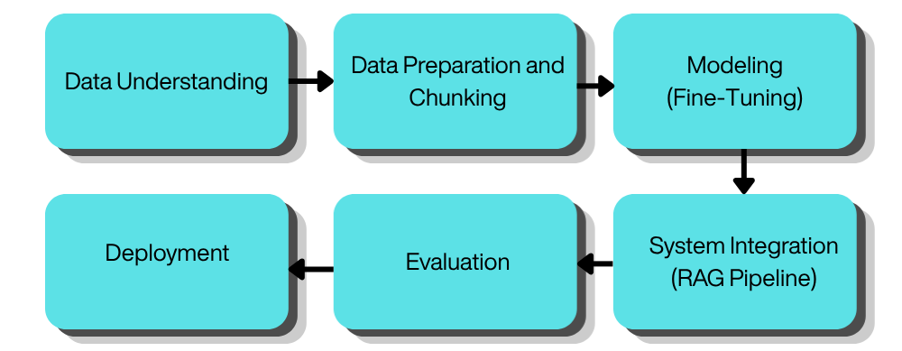
Figure 3.1 Developmental Research Design
Figure 3.1. The figure illustrates the overall developmental research design employed for CIVIL-LEX. The process highlights the overarching framework used to guide the study from conceptualization to continuous refinement. Unlike traditional linear models, this developmental approach ensures that practical feedback continuously shapes the system, minimizing usability friction and ensuring the application remains highly responsive to the actual needs of ordinary citizens.
To systematically execute these overarching design objectives, the software development process specifically adheres to the Cross-Industry Standard Process for Data Mining (CRISP-DM) methodology. This structured and data-centric model is highly appropriate for a complex and high-stakes web application like CIVIL-LEX, wherein multiple artificial intelligence components are integrated to process authoritative datasets of Philippine Civil law.
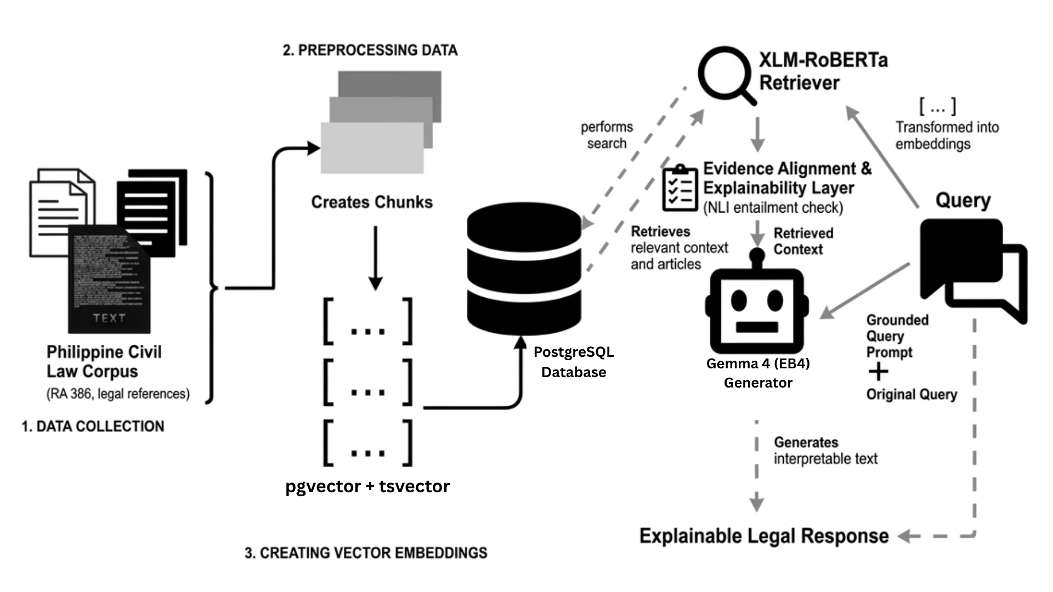
Figure 3.2. CIVIL-LEX RAG Architecture Overview
Figure 3.2. This schematic diagram illustrates the comprehensive data trajectory within the Retrieval-Augmented Generation (RAG) architecture developed for the web application. The procedure initiates with the establishment of the knowledge repository, wherein the statutory provisions of the Philippine Civil Code and augmented legal datasets are systematically preprocessed, encoded into vector representations, and archived within a specialized vector database. During the inference phase, a user-initiated query is transformed into a vector embedding to facilitate the retrieval of the most semantically congruent legal context. This extracted contextual data is subsequently synthesized with the primary query within a structured instructional prompt, enabling the fine-tuned large language model to generate a legally grounded and authoritative interpretation.
To further enhance the system's practical utility, a dedicated Optical Character Recognition (OCR) pipeline utilizing PyMuPDF for digital text extraction and Tesseract OCR as a fallback for scanned documents was seamlessly integrated into the web platform.. This feature allows users to upload scanned legal documents, such as JPG, PNG, and PDF files, for automated text extraction and preliminary analysis directly within their browser.
In the final stages of the development cycle, rigorous Evaluation and Deployment protocols were implemented to validate the web application. This included automated technical evaluation using frameworks like RAGAS or TruLens to measure Context Precision, Context Recall, and Faithfulness. Crucially, the web application employs a dedicated Explainability Layer that executes a Natural Language Inference (NLI) entailment check. This layer replaces arbitrary confidence scores with strict verification that the generated answer strictly aligns with the retrieved text. This diverse group will assess the web application against ISO/IEC 25010 standards, specifically evaluating its functional suitability, usability, and reliability. Their collective feedback will guide the final iterative refinements, ensuring that the CIVIL-LEX web application successfully meets both strict technical benchmarks and the practical, everyday needs of the public.
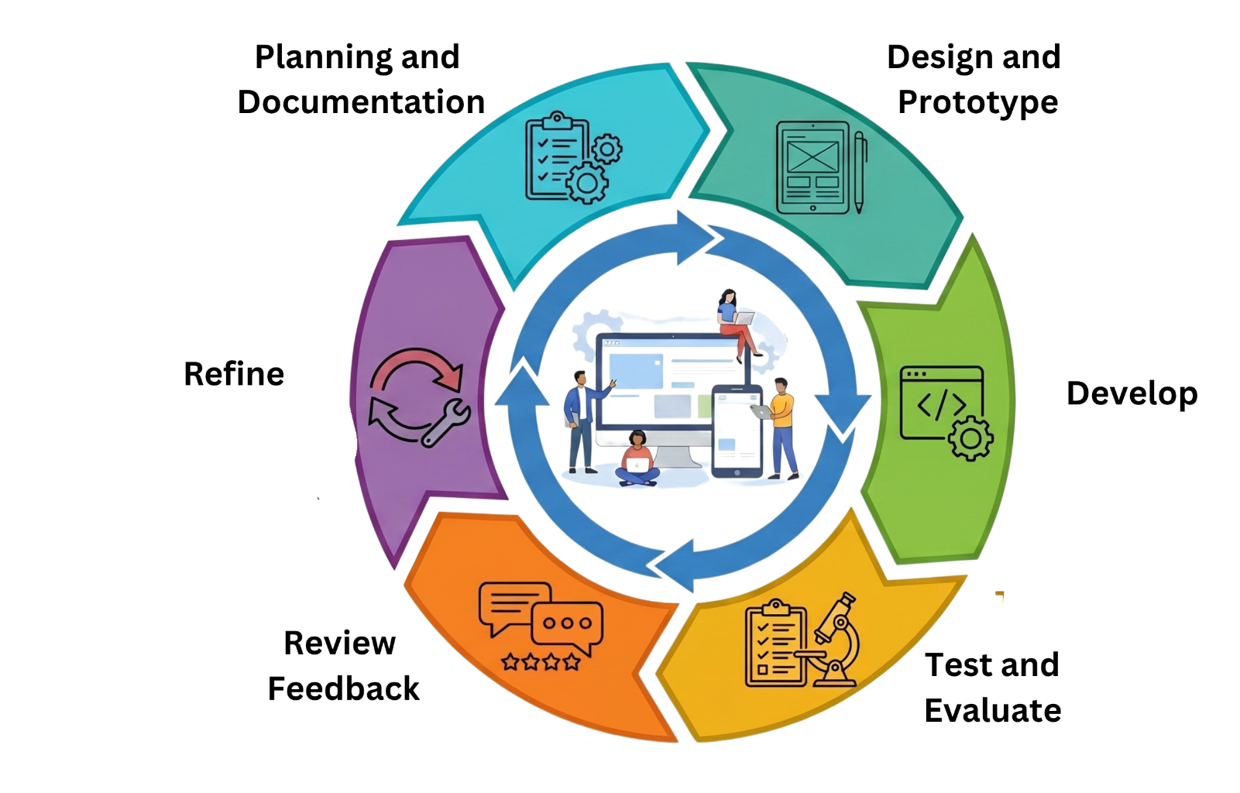
Figure 3.3. Agile
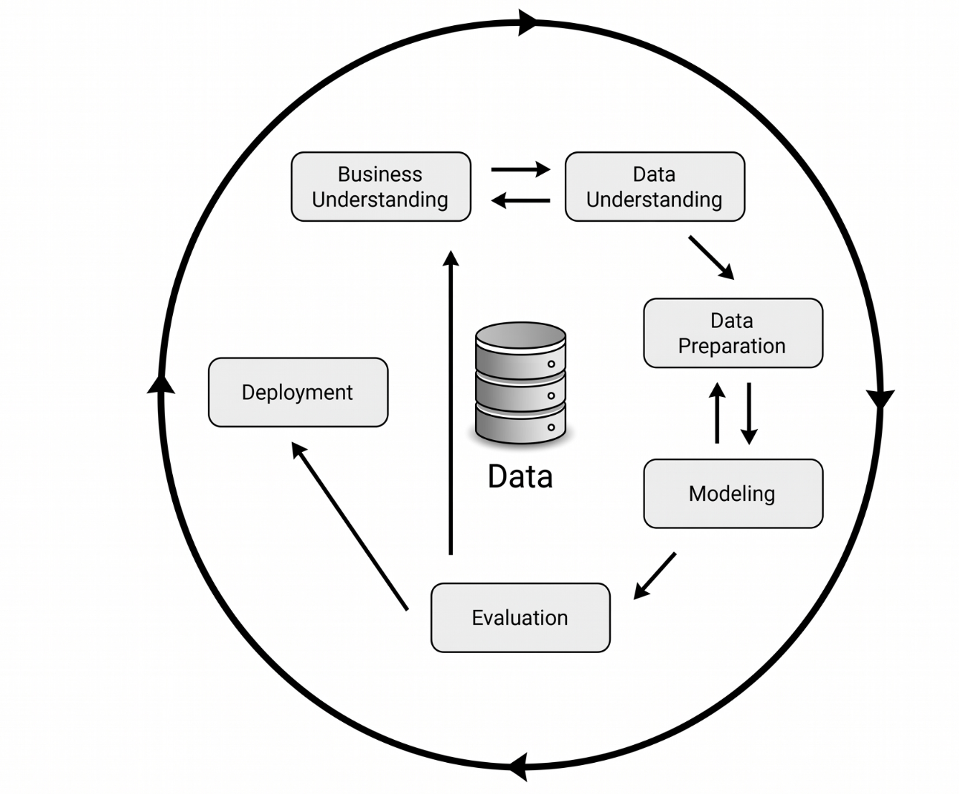
Figure 3.3. This cyclical diagram illustrates the iterative web application development process within the Agile Prototyping lifecycle employed for CIVIL-LEX. The methodology is anchored in a user-centric focus, initiating with a comprehensive analysis of user needs and legal complexities, such as common civil disputes and lease agreements, to define core system requirements. Following this, the design and prototyping phase prioritizes cross-platform compatibility and the minimization of cognitive load, ensuring that the interface maintains strict linguistic accessibility across English, Filipino, and code-switched Taglish queries. To transition these structural designs into a highly functional platform, the development and implementation phase actively integrates critical web application features. This includes the seamless incorporation of persistent conversation memory, heuristic prompt starters, and the dedicated PyMuPDF + Tesseract OCR pipeline to support immediate, browser-based document analysis.. In the concluding, yet continuous, stages of the cycle, rigorous testing and evaluation are conducted to verify the simplified legal interpretations. The empirical insights obtained from these evaluations are immediately fed back into the constant refinement loop, driving further adjustments to the user interface and interaction design to eliminate usability friction and ensure the platform remains highly responsive to the public's actual legal needs.

Figure 3.4. CRISP-DM (Cross-Industry Standard Process for Data Mining)
Figure 3.2. The diagram represents the Cross-Industry Standard Process for Data Mining (CRISP-DM) lifecycle tailored specifically for the CIVIL-LEX project's data science workflow. The workflow progresses through six interconnected phases: Data Understanding, Data Preparation and Chunking, Modeling (Fine-Tuning), System Integration (RAG Pipeline), Evaluation, and Deployment. The backward flow, particularly from the Evaluation phase back to earlier stages such as System Integration and Deployment, emphasizes the risk-driven and iterative nature of the process. This allows developers to continually refine the dataset or retrain the large language models based on performance metrics before the final web release.
The practical execution of this CRISP-DM lifecycle began with the Data Understanding phase to clearly define the parameters of the knowledge base, specifically isolating the Civil Code of the Philippines (Republic Act No. 386). Subsequently, Data Preparation and Chunking was undertaken. The full text of RA 386, comprising the Preliminary Title and all four Books, was collected from official legal repositories. The data underwent a rigorous cleaning and formatting process to remove encoding artifacts, ensuring both consistency and accuracy. This phase was crucial for establishing a high-quality and domain-specific foundation for the model. The legal text was then systematically chunked at the article level, resulting in 2,270 structured records tagged with metadata such as Article Number, Book, and Title. To further enrich this dataset, a large language model was utilized for data augmentation, generating per-article bilingual question-and-answer pairs, reasoning chains, and plain-language simplifications.
Following the extensive data preparation, the Modeling Fine-Tuning and System Integration phases commenced. CIVIL-LEX utilizes a sophisticated hybrid architecture to process the curated legal data. XLM-ROBERTa was selected as the multilingual sentence encoder to manage cross-lingual semantic retrieval efficiently. The system also incorporated Postgresql pgvector to index the 2,270 article embeddings for fast and precise cosine similarity search. For the generative phase, the Gemma 4 (E4B) Instruct model was integrated via LM Studio, with Groq and Gemini Flash configured as cloud-based fallback providers. Ultimately, these distinct components were unified under the Retrieval-Augmented Generation pipeline. This integration allows the web application to ground its generated responses securely in the retrieved Philippine legal statutes rather than relying on generalized and potentially unverified AI knowledge.
3.2. Locale of the Study
The study will be conducted within the Barangay 548, located in Sampaloc, Manila. This area is situated in District IV of the City of Manila and is characterized by a high concentration of residential dwellings and small-scale establishments, with 821 total residents based on the latest records. The researchers selected this locale primarily due to its proximity to the Eulogio "Amang" Rodriguez Institute of Science and Technology (EARIST), allowing for efficient data gathering and accessibility to the target participants.
Barangay 548 serves as a representative urban community where residents frequently encounter legal situations related to civil law, such as tenancy agreements, small-scale contracts, and family-related matters. The diversity of the population in this barangay, ranging from long-term residents to students and transient workers, provides a suitable environment for testing the usability of CIVIL LEX in interpreting legal provisions into simplified Filipino and English.
Furthermore, the barangay hall of 548 acts as the primary frontline for dispute resolution through the Lupong Tagapamayapa. By conducting the study in this locale, the researchers can evaluate how a RAG framework can assist laypersons in understanding their rights and obligations under the Civil Code of the Philippines RA 386 before or during the initial stages of legal inquiry.
3.3. Respondents of the Study
The respondents of this study will consist of ordinary citizens and experts who will be involved in evaluating the CIVIL-LEX system. This classification is intended to capture both user-based and technical perspectives, enabling the study to assess the system from practical usage and professional viewpoints. By including these two respondent groups, the study aims to obtain a balanced and comprehensive evaluation of the system’s overall performance and quality.
The ordinary citizens will comprise the majority of the respondents, representing the primary end-users of the system. Their assessments will provide insights based on actual interaction, usability experience, and everyday use of the chatbot for civil law questions. To match the main goal of the study, these citizens must not have any formal education in law.
In contrast, the experts, although fewer in number, will contribute specialized knowledge and technical judgment in evaluating the system’s design, factual accuracy, functionality, and overall technical soundness. Specifically, the expert respondents will be composed of exactly five (5) professionals: two (2) Information Technology (IT) professionals, two(2) Legal Practitioners (Lawyers), and One (1) Statistician, The IT professionals will be responsible for evaluating the software's architecture and performance based on ISO/IEC 25010 standards. The lawyers will verify the exactness and correctness of the legal interpretations generated by the chatbot. Meanwhile, the statistician will validate the data gathering instruments and ensure that the statistical treatments used in the study are accurate. Their combined participation strengthens the overall validity of the evaluation.
Overall, the inclusion of both ordinary citizens and experts ensures that the findings reflect a holistic assessment of CIVIL-LEX by integrating both real-world feedback from end-users and professional evaluation from technical specialists.
Using Slovin's Formula (Equation 1) with a population of N = 821:
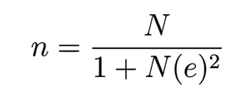
Formula:
(1)

3.4. Research Instruments
The researchers will utilize a triangulated set of instruments to measure the technical performance and user-perceived quality of the CIVIL-LEX framework:
Google Form for System Evaluation: A comprehensive digital survey suite designed to capture data from two distinct respondent groups. For the five (5) expert respondents, the instrument utilizes a 5-point Likert scale to evaluate the framework's technical integrity based on ISO/IEC 25010 standards, specifically focusing on Functional Suitability, Performance Efficiency, Usability, Reliability, and Compatibility. Simultaneously, a simplified System Usability Scale (SUS) component is administered to ordinary citizen respondents to assess the "understandability" and "intelligibility" of legal interpretations, ensuring alignment with the Supreme Court’s SPJI 2022-2027 guidelines.
RAG Evaluation Logs (Automated): Technical logs generated by the system using the RAGAS or TruLens frameworks. These logs capture quantitative data on Context Precision and Recall (to assess the XLM-ROBERTa retriever's ability to find correct articles) and Faithfulness (to ensure the Gemma 4 (E4B) generator does not hallucinate).
Professional Evaluators:
- Legal Subject Matter Expert (SME): A legal professional responsible for manual oversight. They validate the substantive correctness of the generated legal advice to ensure it aligns with established Philippine Civil Law and interpretative doctrines.
- Software Engineer: A technical lead who audits system performance and optimizes the retrieval-augmentation loop. They are responsible for implementing architectural fixes when automated failure signals are triggered, managing the integration between the vector database and the LLM, and ensuring the stability of the end-to-end pipeline.

NLI Entailment Layer: A diagnostic instrument within the software that provides a binary "Grounded" or "Unverified" status, which serves as the primary reliability indicator for the system's output.

Data Gathering Procedure
The data gathering process is structured into three distinct phases: Technical Dataset Preparation, System Deployment, and User Evaluation.
Phase 1: Technical Data Acquisition and Preprocessing
- Legal Corpus Scraping: The full text of Republic Act No. 386 is scraped from official Philippine government repositories to ensure the use of authoritative, verbatim text.
- Structuring and Metadata Tagging: The corpus is segmented into 2,270 article-level records. Each record is tagged with metadata, including Article Number, Book, Title, and domain tags for Obligations, Family Law, or Property.
- LLM Data Augmentation: A Large Language Model is used to enrich the dataset with bilingual Q&A pairs, reasoning chains, and text simplifications.
- Jurisprudence Extraction: Verified Supreme Court decisions (G.R. numbers) are manually linked to articles to provide real-world interpretive context
- Data Validation by Legal Professional: A licensed Legal professional validates a representative sample of at least 100 augmented article records, checking factual accuracy, domain tag correctness, appropriateness of examples and caveats, and integrity of manually linked Supreme Court decisions. Any flagged records are corrected and re‑reviewed before the dataset is considered suitable for model training.

Phase 2: System Deployment and Participant Selection
- Web Deployment: The CIVIL-LEX prototype is hosted as a web application, accessible via standard browsers without installation
- Participant Recruitment: Respondents are sourced from the Sampaloc, Manila district, representing a mix of students, local families, and small business owners.
- Authentication: Users must register and sign in via Supabase Auth to access the chat interface, ensuring a secure and authenticated testing session.

Phase 3: Evaluation via Google Forms and System Logs
- Interaction Session: Respondents engage with the chatbot by entering natural language queries in Filipino, English, or "Taglish," or by uploading legal documents for OCR analysis.
- Real-Time Data Capture: As the users interact, the RAG pipeline automatically logs performance metrics and NLI entailment scores for later analysis.
- Survey Distribution: Upon completion of the testing session, a Google Form link is provided to the participants:
Experts: Receive the link to the ISO/IEC 25010 Evaluation Form to provide technical judgment.
Ordinary Citizens: Receive the link to the Usability and Comprehension Form to share their experience.
- Data Consolidation: Responses from Google Forms are exported to a spreadsheet for statistical treatment, while system logs are analyzed to determine the framework's overall accuracy and reliability.
3.5. Data Analysis Tools
To ensure the technical integrity of CIVIL LEX, the research team implements a rigorous data preparation pipeline focused on transforming raw legal text into a high-quality, machine-readable format using JSON as the primary data structure. This process is essential to establish a reliable system foundation, where every legal provision must undergo meticulous cleaning and organization before being utilized for retrieval and generation. Data Normalization and Statutory IntegrityThe cleaning phase initiates with the scraping of the full text of Republic Act No. 386 from official Philippine government repositories to ensure the use of authoritative, verbatim text.
The acquired data undergoes a normalization process where encoding artifacts, special characters, and formatting inconsistencies common in legacy legal documents are removed. While the text is scrubbed for technical consistency, the research team maintains verbatim preservation of the statutory language to ensure legal traceability and factual accuracy. A critical component of this stage is Amendment Integration, where provisions are explicitly updated and cleaned to reflect superseding amendments, such as those from the Family Code of the Philippines (E.O. 209), ensuring the knowledge base remains legally current.

Article-Level Chunking and Semantic Enrichment
Following the normalization of the corpus, the data is systematically segmented through article-level chunking, resulting in 2,270 structured JSON records. Each JSON object is tagged with specific metadata, including the Article Number, Book, Title, Chapter, and domain tags (e.g., Obligations, Property, or Family Law) to facilitate high-precision retrieval. To bridge the gap between technical legal jargon and public comprehension, each record is further enriched through a bilingual enrichment process. This involves utilizing Large Language Model (LLM) augmentation to generate bilingual Q&A pairs, Chain-of-Thought (CoT) reasoning chains, and plain-language simplifications in both Filipino and English. Finally, verified Supreme Court jurisprudence entries and G.R. numbers are manually linked to the articles to provide real-world interpretive context, ensuring the dataset is both technically robust and legally grounded.

3.6. Statistical Treatment of data
The following statistical tools are used to analyze data collected from the ordinary citizen respondents and five expert respondents in evaluating CIVIL LEX against selected ISO/IEC 25010 quality characteristics and RAG pipeline performance.

Frequency and Percentage Distribution
Used to describe respondent profiles and summarize Likert-scale response distributions across all ISO/IEC 25010 quality characteristics.
(2)
P = (f / N) × 100

where P is the percentage, f is the frequency of a given response, and N is the total number of respondents.
Weighted Mean
Used to compute the average evaluation score per quality characteristic using a five-point Likert scale (5 = Strongly Agree, 1 = Strongly Disagree).
(3)
x̄ = Σ(wᵢ × fᵢ) / N
where wᵢ is the Likert weight for response category i, fᵢ is the corresponding frequency, and N is the total number of respondents. Scores are interpreted using the following scale:
Table 3.1 Scale Interpretation
Range | Interpretation | Description
4.50 – 5.00 | Strongly Agree | Quality characteristic is excellently satisfied.
3.50 – 4.49 | Agree | Quality characteristic is satisfactorily met.
2.50 – 3.49 | Neutral | Quality characteristic is partially addressed.
1.50 – 2.49 | Disagree | Quality characteristic is minimally satisfied.
1.00 – 1.49 | Strongly Disagree | Quality characteristic is not satisfied.

Table 3.1 illustrates the scale interpretation used to assess the degree of compliance with ISO/IEC 25010 quality attributes.
Standard Deviation
Used to measure the degree of agreement among respondents per evaluation item. A value below 1.00 indicates sufficient response consistency.
(4)
SD = √[ Σ(xᵢ − x̄)² / (N − 1) ]
RAGAS Automated Metrics
The following automated metrics from the RAGAS framework evaluate the accuracy and reliability of the CIVIL LEX RAG pipeline (Research Question 3):
Table 3.2 RAGAS metrics
Metric | Formula | What It Measures
Context Precision | TP / (TP + FP) | Relevance of retrieved articles
Context Recall | TP / (TP + FN) | Completeness of retrieval
Faithfulness | (Supported Claims) / (Total Claims) | Groundedness of generated answer
Answer Relevance | cos(E_answer, E_query) | Alignment of answer to query
Table 3 presents the RAGAS metrics used to evaluate the performance of the retrieval-augmented generation (RAG) pipeline.
A minimum score of 0.70 is set as the acceptable threshold for all RAGAS metrics, with a target score of 0.80 or above. Faithfulness is additionally validated through the system's built-in Natural Language Inference (NLI) Entailment Check, which flags each generated answer as 'Grounded' or 'Unverified' based on strict statutory grounding.
XLM-RoBERTa Retriever - Classification Metrics
To evaluate the accuracy and reliability of the fine-tuned XLM-RoBERTa retriever (Research Question 3), standard classification metrics are applied. Each retrieved article is labeled as a True Positive (TP) if it is relevant and retrieved, True Negative (TN) if it is irrelevant and not retrieved, False Positive (FP) if it is irrelevant but retrieved, or False Negative (FN) if it is relevant but not retrieved.
Table 3.3. Evaluation metrics
Metric | Formula | What It Measures
Accuracy | (TP + TN) / (TP + TN + FP + FN) | Overall correct retrieval rate
Precision | TP / (TP + FP) | Proportion of retrieved articles that are relevant
Recall | TP / (TP + FN) | Proportion of relevant articles that are retrieved
F1-Score | 2 × (Precision × Recall) / (Precision + Recall) | Harmonic mean of Precision and Recall
Table 3.4 illustrates the evaluation metrics and corresponding formulas used for retriever performance assessment, shows an F1-Score of 0.80 or above is set as the acceptable threshold, balancing retrieval completeness and precision for civil law provisions. These metrics are computed on the labeled 50-query PoC test set and the full evaluation dataset.
The accuracy and reliability of the Gemma 4 (E4B) generator are evaluated using the following text generation metrics (Research Question 3), applied against human-annotated reference answers verified by legal practitioners.
Table 3.4 Generation Quality Metrics
Metric | Formula / Description | What It Measures
BLEU Score | BP × exp(Σ wₙ × log pₙ) where BP = brevity penalty, pₙ = n-gram precision, wₙ = uniform weight (1/N) | N-gram overlap of generated answer with reference
ROUGE-1 | Unigram recall: |Generated ∩ Reference| / |Reference| | Word-level coverage of reference content
ROUGE-2 | Bigram recall: |Bigrams(Gen) ∩ Bigrams(Ref)| / |Bigrams(Ref)| | Phrase-level overlap with reference
ROUGE-L | F-measure based on Longest Common Subsequence (LCS) between generated and reference answer | Fluency and structural similarity
BERTScore F1 | F1 of token-level cosine similarities between contextual embeddings of generated and reference tokens (via multilingual BERT) | Semantic similarity beyond exact word match
Perplexity (PPL) | PPL = exp(−(1/N) × Σ log P(tᵢ | t₁...tᵢ₋₁)) where N = number of tokens, P = model probability | Model confidence; lower PPL = more fluent output

Table 3. presents the generation quality metrics used to assess the performance of the Gemma 4 (E4B) model. For BLEU and ROUGE, a score of 0.40 or above is considered acceptable for legal text generation, where precision is more important than verbatim reproduction. A BERTScore F1 of 0.85 or above is targeted to confirm semantic equivalence with legal practitioner reference answers. Perplexity is used to measure the model's confidence and fluency on Philippine civil law content, with a lower perplexity indicating more fluent, on-domain output.
System Reliability Metrics
To evaluate the operational dependability of the CIVIL LEX system, the following reliability metrics are measured during sustained load testing and simulated user sessions on the deployed RAG pipeline.
Table 3.5. Reliability Metrics
Metric | Formula | What It Measures
Error Rate | (Failed Responses / Total Requests) × 100 | Percentage of queries that returned failed or invalid responses
System Uptime | (Total Time − Downtime) / Total Time × 100 | Availability of the system as a percentage of total observed runtime
Mean Time Between Failures (MTBF) | Total Operational Time / Number of Failures | Average time the system operates without encountering a failure
Table 6. Illustrates the reliability metrics and their corresponding formulas and measurements, An Error Rate below 5% and a System Uptime of 99% or above are set as the acceptable thresholds for production reliability. MTBF is used as a comparative indicator across test sessions to assess system stability under sustained use.
Response Time Metrics
The following metrics capture the latency profile of CIVIL LEX across different stages of query processing, from initial token generation to full response delivery.

Table 3.5.Response Time Metrics
Metric | Formula/Description | What It Measures
First Token Time (FTT) | Time elapsed from query submission to generation of the first response token | Initial system responsiveness and retrieval latency
Total Response Time | Time elapsed from query submission to complete response delivery | End-to-end latency per query
Average Response Time | Σ(Response Timeᵢ) / N, where N = total number of test queries | Mean latency across all evaluated queries
95th Percentile Response Time (P95) | Response time value below which 95% of all queries fall | Worst-case latency experienced by the majority of users
Table 3.5 Presents the key response time metrics used to evaluate system performance .A Total Response Time of under 10 seconds and a 95th Percentile Response Time (P95) below 15 seconds are set as the acceptable thresholds, reflecting the expected tolerance of legal query users for deliberate, statute-grounded responses.
Throughput Metrics
Throughput metrics assess the capacity of the CIVIL LEX system to handle concurrent and high-volume query loads without degradation in response quality or reliability.
Table 3.6 Throughput Metrics
Metric | Formula/Description | What It Measures
Queries Per Second (QPS) | Total Queries Processed / Total Elapsed Time (in seconds) | Maximum query processing capacity of the system under load
Concurrent User Support | Maximum number of simultaneous users handled without degraded response quality or system failure | System scalability under parallel demand
System Capacity | Peak number of requests handled within a defined time window before error rate exceeds threshold | Upper bound of load the system can sustain reliably
Table 3.6 shows the Queries Per Second (QPS) and Concurrent User Support are measured using simulated load tests, with acceptable thresholds determined relative to the projected user base. System Capacity is used to identify the saturation point beyond which reliability and response quality degrade below acceptable levels.
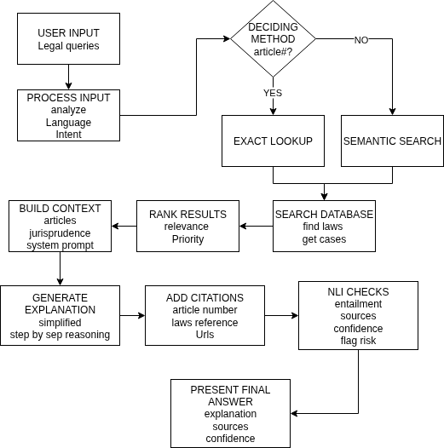
3.7. Proof of concept

Figure 3.5 Proof of Concept
Figure 3.5 Illustrates the proposed Proof of Concept of the CIVIL LEX system, demonstrating the feasibility of a Retrieval-Augmented Generation (RAG) approach for legal question answering. The process begins with user input in the form of legal queries, which are analyzed to determine the user’s intent. Based on this analysis, the system decides whether the query requires an exact article lookup or a broader semantic search. The selected method retrieves relevant legal provisions and jurisprudence from the database, after which the results are ranked according to relevance and priority. A contextual input is then constructed by combining retrieved articles, jurisprudence, and system prompts. The system generates a simplified explanation with step-by-step reasoning, followed by the inclusion of appropriate citations such as article numbers, legal references, and source links. To ensure reliability, an NLI (Natural Language Inference) check is performed to verify consistency between the generated response and the source materials, while also assessing confidence and potential risks. Finally, the system presents the answer to the user, including the explanation, supporting sources, and a confidence indicator, thereby demonstrating the core functionality and feasibility of the proposed system.

Wireframe
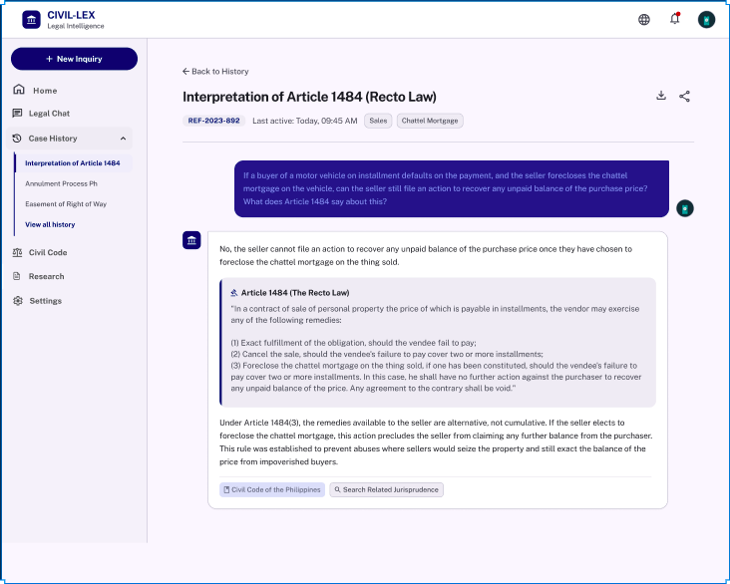
Figure 3.6 Case History
Figure 3.5. Shows the case history module of CIVIL-LEX, where users can review and manage their previous legal inquiries and generated explanations.

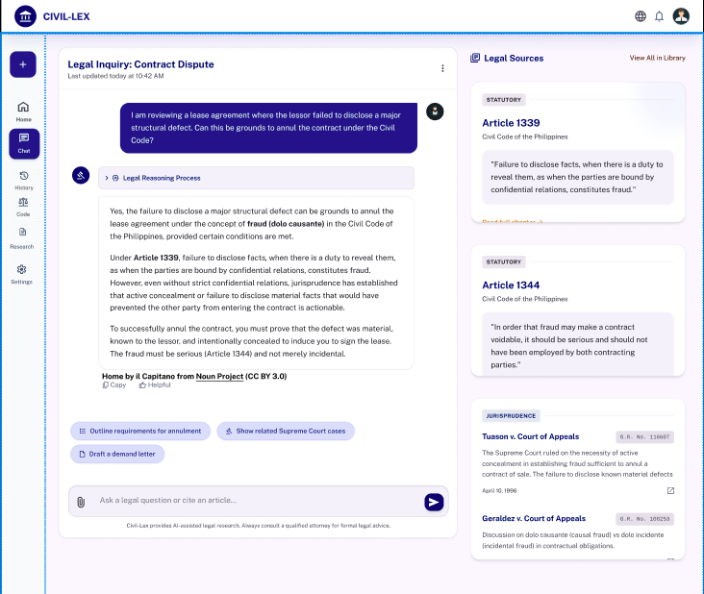
Figure 3.8 Chat Inquiry
Figure 3.8 illustrates the main Chat Inquiry interface, detailing how the generated legal explanation is presented alongside its corresponding legal sources and citations after a user query is submitted.

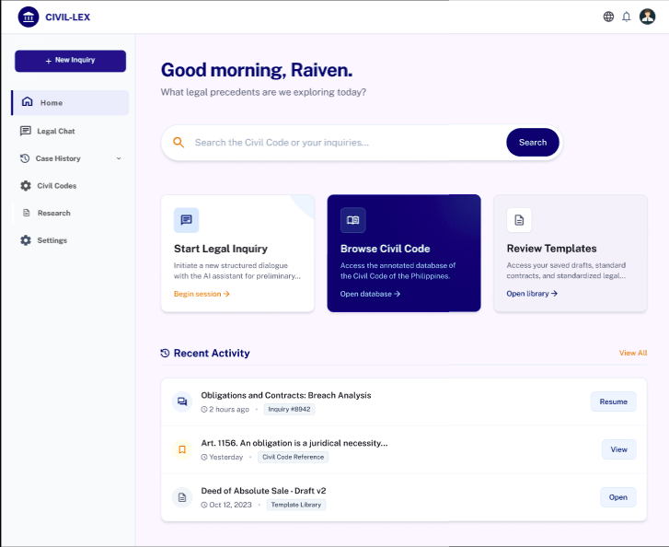
Figure 3.9 Homepage
Figure 3.9 illustrates the Homepage interface, which features the primary chat entry point and a display of the user's recent activity for quick access to previous inquiries.
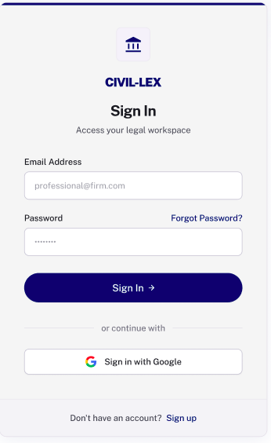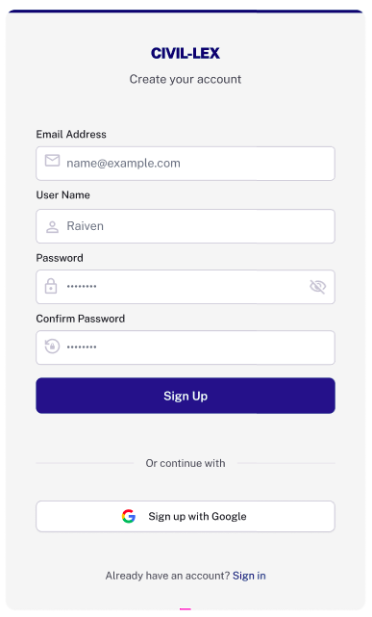
Figure 3.10 Log in and Sign up
Figure 3.10 illustrates the Log-in and Sign-up Authentication Interface, which manages user credentials and ensures session persistence for saving conversation history.

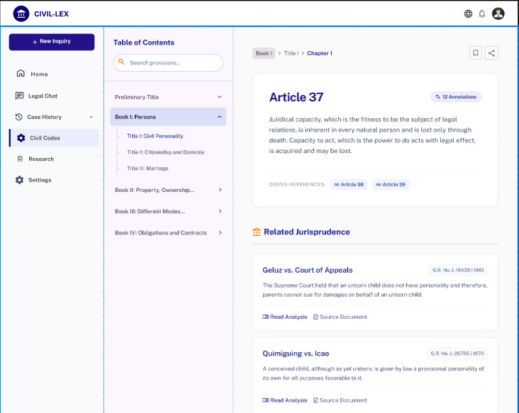
Figure 3.11 Civil Codes
Figure 3.11 illustrates the page where users can browse the complete Philippine Civil Code, covering Books I to IV, along with their corresponding jurisprudence
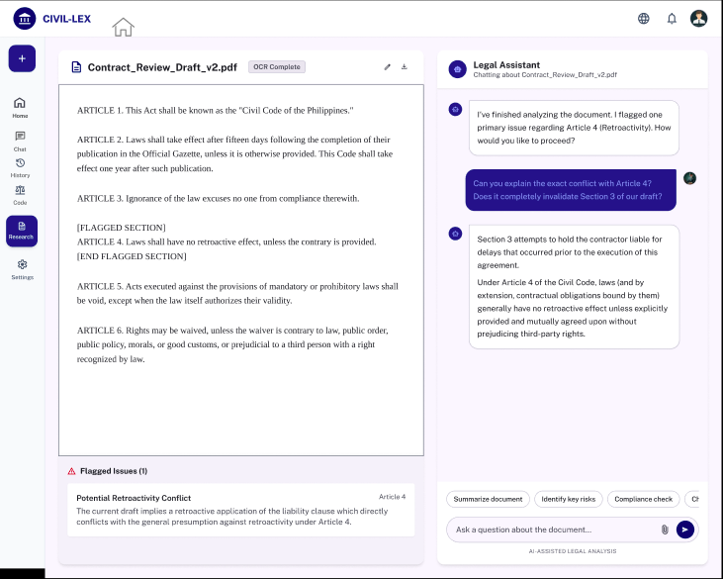
Figure 3.12 Research
Figure 3.12 illustrates the Research page, where the user can view the uploaded document after it has undergone OCR processing. The interface displays the extracted text alongside identified sections and flagged issues. Additionally, users can interact with the integrated chatbot, which analyzes the opened document and enables discussion, clarification, and deeper understanding of the paper’s content.
CHAPTER 4
Presentation, Analysis And Interpretation Of Data

